Parts of the project: 🡪 predict parts of bindings of drugs to its target.

* Introduction
* Statistics
* ….

STRUCTURAL BIOINOFORMATICS

Table of Contents

1. Introduction 3

1.1. Amino acids 3

1.2. Peptide bond 4

1.3. Native conformation 4

1.4. Levels of structure 4

2. Energy 4

2.1. Bondign energy terms 4

2.2. Non-Bonding terms 5

Hydrogen Bonds 5

3. Secondary Structure 5

3.1. Strands 5

3.2. Helix 5

3.3. Ramachandran Plot 5

3.4. Aa propensities 6

Protein structure II 8

Soluble and globular porteins 8

Principles observed in folds 8

classical folds 9

PRINCIPLES OF PROTEIN STRUCTURES AND CONFORMATIONAL SPACE

# Introduction

## Amino acids

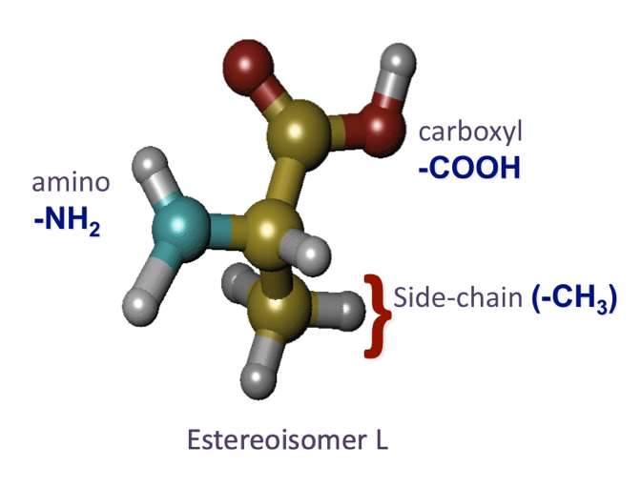The **side chain** is the most important part of the aa, give the properties of the amino acid. Also have a carboxyl group and an amino group. If we place the amino group in the hydrogen position, that would be a different molecule, a stereoisomer. All aa are **stereoisomers** of kind L.

Alpha carbon

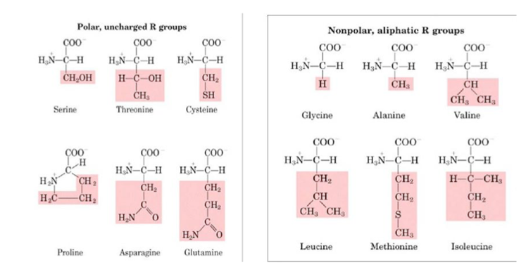

The polar aa likes water and the apolar or aliphatic likes more oil. In this table we classify the aa if they are polar or not. So we will define the polar properties of an aa depending on the solubility of the aa in water.

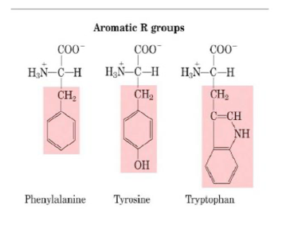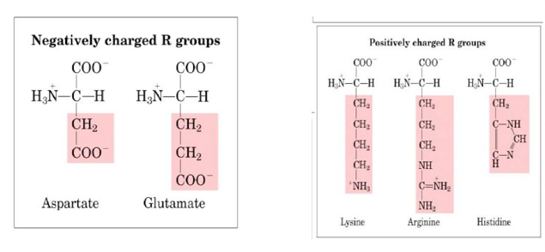

The aromatic groups do hybridization and have electromagnetic properties. Usually form pi-pi interactions usually happening to DNA. AA join together to form a polypeptide reaction that produces water, forming the **peptide bond**. The carbon makes a bond with the amino group. This is a very special bond. If we look at he the chemical structure of the N and C, we have a sp2 for the N and for the C, and that means that they release a pi orbital. Once produce a single bond, this orbital pi produce a partial double-bond[1]. This C-N bond is stronger so it cannot rotate freely, because of the delocalized electrons, the more delocalized electrons, lower energy, and more stable, so as a result, harder to break. he importance of it, is that it cannot rotate, and that is going to be important for the conformation of the whole polymer. We cannot rotate the pi-pi bond, and that’s important when looking at the structures, as the only rotable parts are the alpha carbon, the other ones are fixed. The partial double-bond character makes the peptide bonds planar, strongly affecting 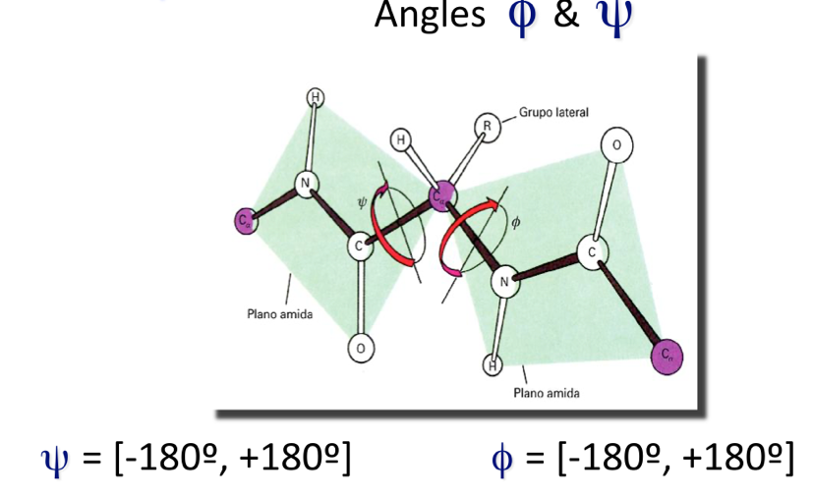protein folding and structure and is essential for forming alpha-helices and beta-sheets. The angles around the alpha carbon are the only ones that can freely rotate. This are known as **phy and psi angles**.

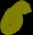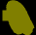

### Native conformation

Depending on the environment of the protein (if it’s in water) will change the conformation to get stabilized.

### Levels of structure

Primary structure 🡪 Secondary structure 🡪 Tertiary structure (fold of the protein once is placed in water)🡪 Quaternary structure

Secondary structures are regular structures and classically are alpha helix or beta strands. Super secondry-structures are called motifs.

The tertiary structures interact with other proteins forming the quaternary structure. And the quaternary structures are called superestrctures.

# Energy

## Bonding energy terms

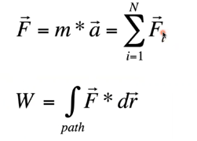These regularities can be explained by energy. This formula is the Newtons law (F), which represent the sum of force in that atom (for instance). The we define work (W) as a path integral, amount of this force * by the space of that atom when these forces are applied.

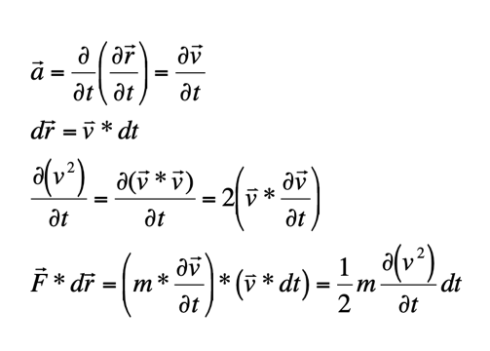Acceleration is the derivative of velocity along time.

Ep= Potential energy

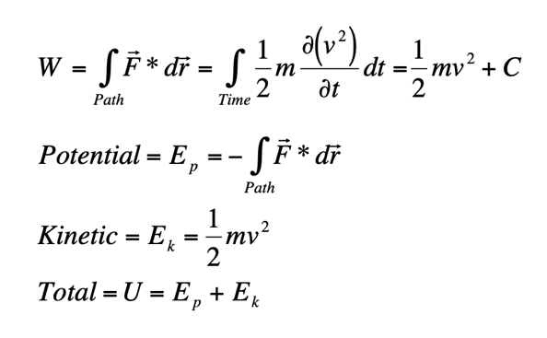Ek= kinetic energy

U= total energy

The faster the atoms will move, the higher the temperature is going to be, so by increasing the temperature, increase the kinetic energy. And the potential energy must drop down because the total energy (U) is constant.

We are going to use this to run molecular dynamics keeping the constant energy and heating up increasing the kinetic energy. This is called **annealling**, heating and colds, having different conformations of one structure. The kinetic is linked to temperature and the potential energy describes the whole system.

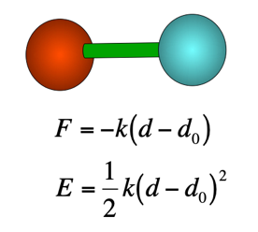This is the typical bond between two atoms. The system tends to put back where they were, and if we pull one atom, there’s a tendency to get back the atom to the original position. This is the formula describing the force.

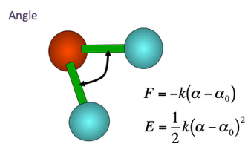What is this potential energy? First, we have an interaction between two atoms, behaving like a screen.

Another term is the angle, and in this case we have 3 atoms. Here if we compress the two blue atoms, the force is the same, so same formula.

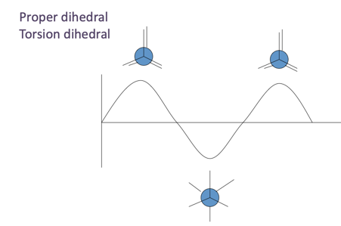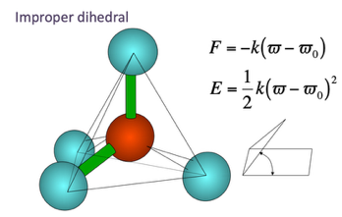If the 3 bottom atoms go up, like an umbrella, there’s a tendency to pull the atoms down. We need to define the angle, either presing or pulling, the behaviour is try to get back where it was.

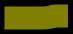

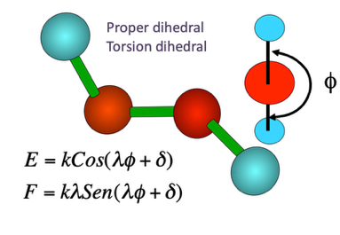

The proper dihedral, and moving this molecule forms a sin and cos, showing the highest and the lowest energy.

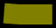

## Non-Bonding terms

One non-bonding terms is the interaction between + and – charges. When two atoms don’t like each other, repelling = high energy.

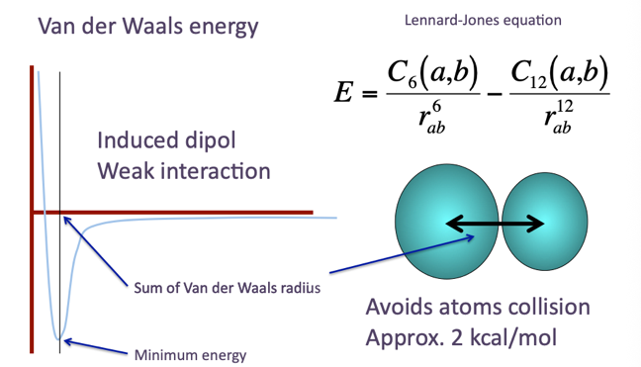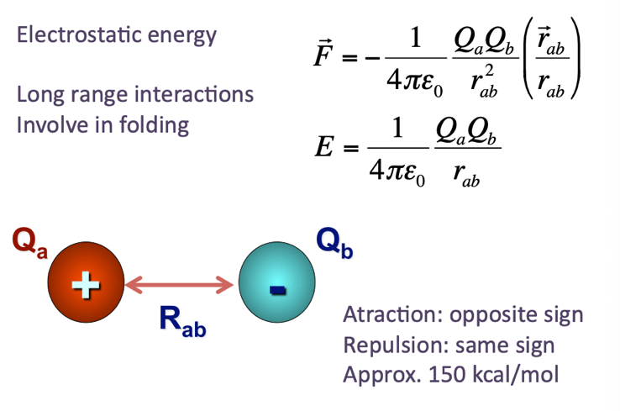

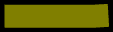

Coulomb formula for the force. Indirectly proportional to the distance and directly proportional to the charges.

Atoms do not clash each other, they cannot occupy the space of another. When the clouds of electrons of one atom moves to one direction and the cloud of electrons of the other atom moves to the other, it behaves as a dipole and makes an induction. Atoms have a tendency at some point to be close, but not much, and the behaviour is like is represented in the plot.

The Van der Waal forces are attractive and repulsive forces that determinate the character of many organic compounds and their solubility in polar and non-polar disolvents. The dipole-dipole are attractive and repulsive interactions between polar molecules, molecules that have a dipolar moment. And if a molecule has a dipolar moment approximates to an apolar molecule without a dipolar moment, it will deformate its electronic cloud. The polarization of a neutral specie will depend on the polarization capacity (alpha) and the dipolar moment (mu) of the dipole. It is only important in short distances

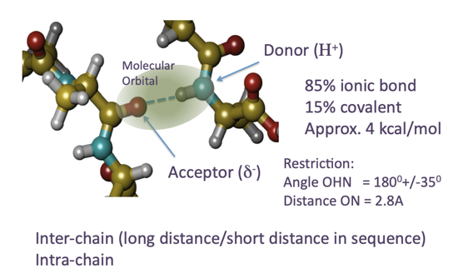Then, about non-bonding terms there are some special ones, like the **H bond**. Most important in proteins. Oxigen suck the electrons from the cabron and gets – charged, is not a real charge, just a tendency. The electrons of the oxygen can start being shared by the proton of the H, and then the orbital produce a bond, a covalent bond. That’s not really a covalent bond, only 85% is an ionic bond and a 15% is covalent. The energy for this bond is 4 kcal/mol, and the most important thing is one of the properties that forces this orbital, and if this is an orbital it mean that this cannot be bent.

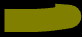

# Secondary Structure

## A diagram of a molecule AI-generated content may be incorrect.Strands

H bonds acts like a zip. To do so, twist and the side chains looks up wards or down wards forming a beta-sheet.

The side chains in the beta sheet are looking up and down.

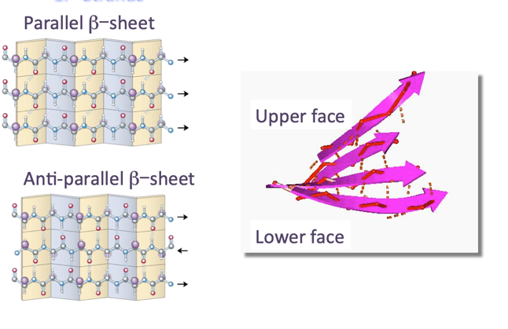



Polymeric chain

## Helices

What happen if the H bonds are near the residues? For instance, residue 1 makes H bond with residue 4, that means a difference of 3 residues. That’s turn 3, and if we 4 for residues in between, that’s 4 turns. If we repeat this turns, we form a helix. The first one is **helix 310** and the second is called **helix alpha** and this last one is more stable because is more relaxed. Acts like a “castellers”, the more people, the bigger the whole, and the more unstable it gets, so that’s the reason why 5 turns is a bit difficult (**helix pi**).

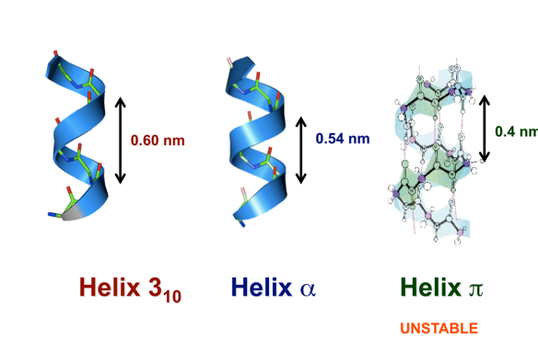Important to recognize the length (for instance in a lipid membrane).

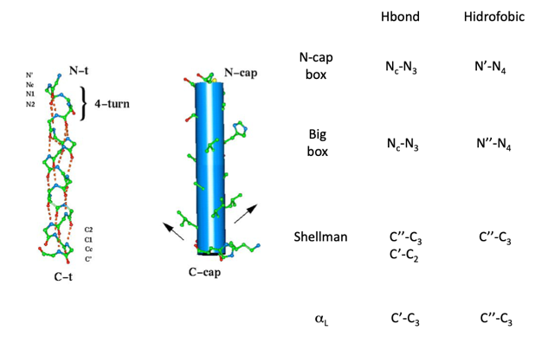

At some point the helix has to finish, so the helix has an overstabilization in the N-caps or in the C-cap. So it is needed stabilization in the extremities, because if not, H bonds will break and change of the conformation. Depending on how do this parts are broken, there’re different types.

Nc 🡪 caping

N1 and N 🡪 first and second in the helix

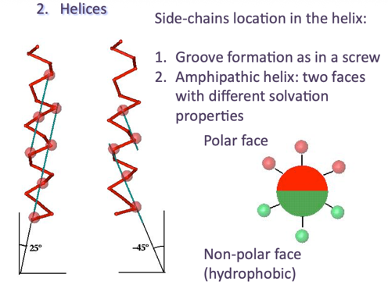N’-N4 is a hydrophobic interaction that substitutes a H bond, so that makes a very stabilized form. In the N-terminal part will be + charged and the C-terminal will have a - charge, and to stabilize the helix, add residues – charged in the n-cap and + charged in the C-cap to stabilize the dipole, and consequently the helix.

One face of the helix is hydrophobic and the other face is hydrophilic, so the helix is **amphipathic**. Look at how the side chains are placed with respect to the axis of the helix, so we can see some angle at -25º and the other atoms, the angle is different, -45º with respect to the axis.

## Ramachandran Plot

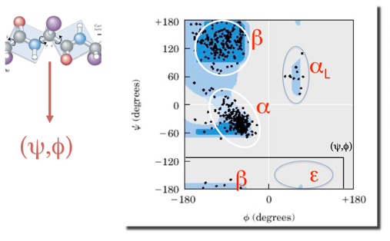The aa are going to be placed in such a conformation to make H bonds and regular secondary structure, and are called regular because they have been seen very often, because they have this H bonds that stabilize ethe interaction (in the case of beta strands and helix). If we plot in a two dimensional diagram, phy and psi in the axis, each dot is an aa, we will se which regular secondary structures they are. Each protein has its own Ramachandran plot. If we see dots outside the areas, does not occur very often and it is considered weird.

## Aa propensities

Certain aa occur very often in specific secondary structures:

Why Pro and gly does not have alpha helices?

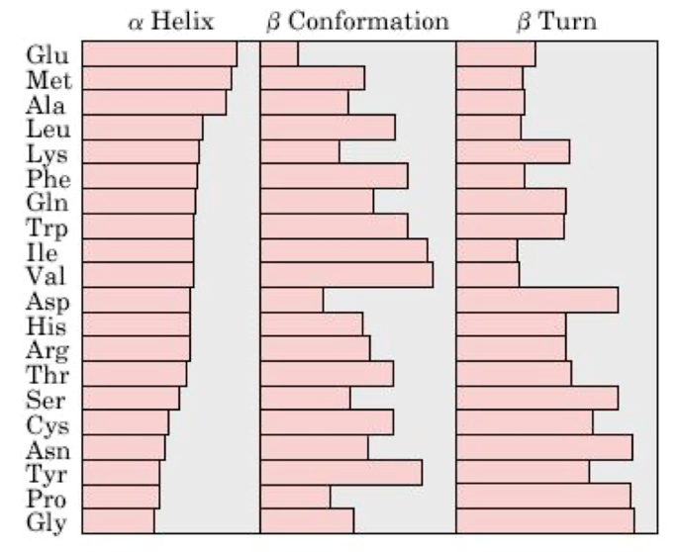Pro: When making a peptide bond, it will have a bond with the only N, pro do not do H bonds. So if there’s a pro I the middle of an alpha helix, this will be broken.

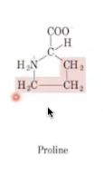And gly does not have a side chain.

Beta-turn is a short turn of the polipeptidic chain that can do the change of direction

# 2. Protein structure I

## 2.1. Escleroproteins

This are specific set of proteins, we obtain very easily the structure of this proteins because they are fibres, without doing crystallography.

### Alpha-keratin

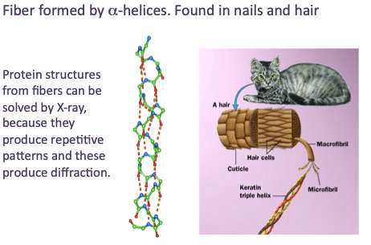



### Fibroine

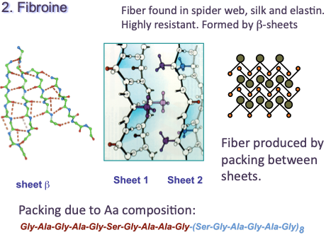Formed by secondary structures.



### Collagen

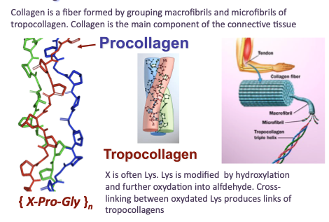



## Principles of thermodynamics

The most important proteins are the globular ones.

### State functions

The state of a system is described by means of macroscopic variables: N (num of molecules), p (pressure), T, V, U (total energy). These variables are known as **thermodynamic variables**. If the variables are independent, then they are known as state variables. Any function described by means of thermodynamic variables are known as state functions, in other words, combining any of these thermodynamic variables that produces a function that can be considered as a state function. The difference of a state function between two states is independent of the path driving one state to the next.

There is a state function such that it gets always the maximum of the system in the absence of restraints. This function is named **entropy**. It follows that the entropy of an isolated macroscopic system never decreases. The second law states that spontaneous natural processes increase entropy overall. A system is in **thermodynamic equilibrium** when the macroscopic variables describing the system are independent of time. Examples of state functions:

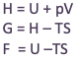

### Statistical thermodynamics

1. **Microstate**: State of a system specified by means of the coordinates and velocities o each particle.
2. **Macrostate**: State of a system specified by means of thermodynamic variables.
3. **Hypothesis**: all microstates of a system are equally accessible with the same probability
4. The **thermodynamic probability (W)** is defined as the total number of microstates accessible by the particles of an ensemble in the same microstate.
5. **Boltzmann hypothesis**: Entropy (S) can be defined as a function of the thermodynamic probability (W), this is S=f(W)

### A math equations with black text AI-generated content may be incorrect.Entropy and Boltzman equation

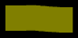

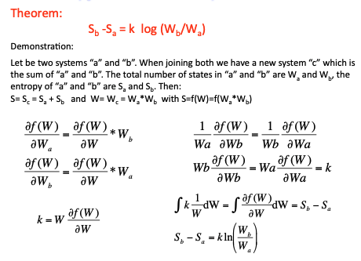

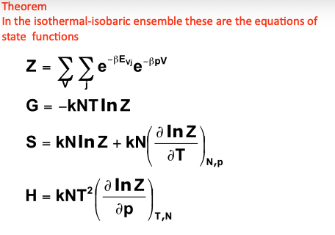P is the probability of each microstate.

Gibbs energy

## Soluble and globular proteins

The most important proteins are the spheroporteins (globular shape) and they are soluble. An example of globular proteins is myoglobin, and by doing crystallography it can be studied its structure. On the outside has polar residues and, on the inside, has. Hydrophobic core, in which there is allocated the porphyrin.

### Protein folding

#### Hydrophobic effect

The higher the disordered atoms, the higher the entropy. So, what happens with proteins?

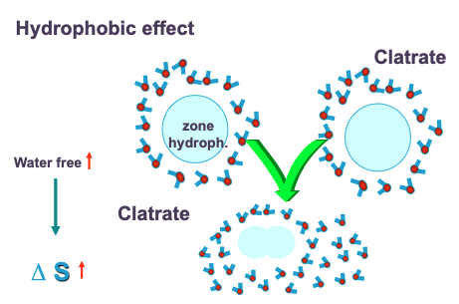Wen joining two drops od oil in water, the result is that the molecules of water will be surrounded the bigger oil drops, so more molecules of water recovering the system, more degrees of freedom, and more entropy. And that happens the same with proteins. Proteins have a hydrophobic part and the more water particles surrounding the protein, higher degrees of freedom of water molecules. That’s why proteins fold in an water environment, otherwise they would not fold.

#### Disulphide bridges

There are other interactions apart from the hydrogen bonds (specific for secondary structures), and for the folding there are other interactions such as disulphide bridges.

### Protein folds

There are different ways in which we can produce protein folds, by joining alpha helices, beta and alpha, only beta, etc.

### Super secondary structure

#### Definition

How this different structures produced?

**Motif or super-secondary structure** it’s a construction produced by a cluster of 2-4 regular secondary structures, usually involved in a particular function. **Loops** are highly flexible and produce change of the polypeptide chain orientation, and the length of the loops varies from 1 to more than 40 residues. Some super-secondary structures are stabilized with a hydrophobic core.

#### α – α

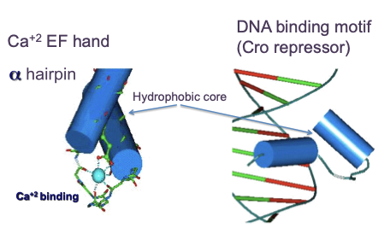



#### β – β

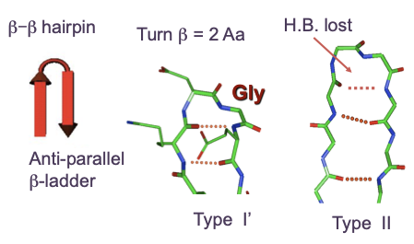



#### β – α & α – β

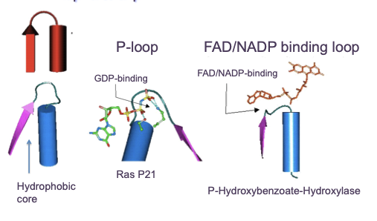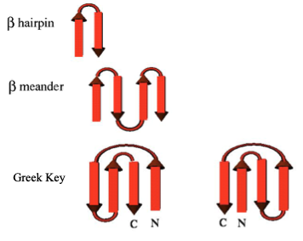



Some residues in the P-loop are lys and ser that bind the phosphates of GDP. Another classical motif is the FAD/NADP binding loop, it also has a beta and alpha and in the loop it has gly and takes the shape of the FAD or NAD.

#### β – α – β

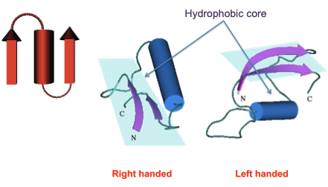

I cannot superpose the right handed structure with the left handed structure.

### Domains

#### Definition

The **protein domain** is defined as the fundamental unit of 3D structure, able to fold by itself in the right conditions with independence of the rest of the protein. It often corresponds to functional local and compact units of a protein.

#### Classification

We have different classifications of these domains. One protein can be constructed by several domains, each domain can be constructed by several super-secondary substructures, and each supoer-secondary subestructues is constructed by 2-4 regular secondary substructures.

If the domain is mostly constructed by alpha, is considered all alpha type structure and vice versa for beta.

* If there are alpha-beta: type of fold called **alpha/beta**
* If there’s one region for the alpha and one region for the beta, they are split, it is called: **alpha+beta**

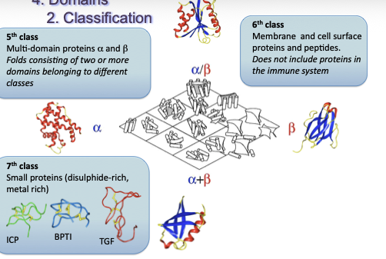

#### Function-Sequence-Structure

In order to classify this folds, let’s analyze the sequence this two proteins in principle you would say that they are different, but taking a look in the sequence, they look so different, but superimposing both proteins, sima patterns are conserved. That means that both proteins are homologs sharing a common ancestor.

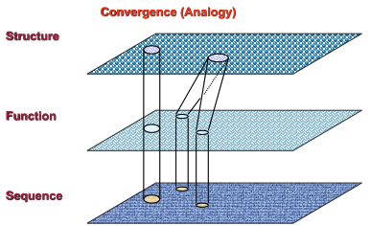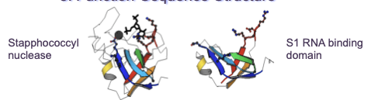

The first case is when having some seq more or less the same, they have same function and same structure, and that would mean that have a common ancestor 🡪 **orthologs**

The second case is when different seq with dif functions but same structure (no homology, no common ancestor) 🡪 **analogs**

Same family

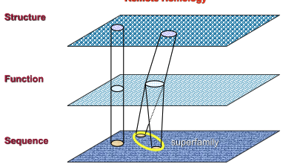

This second case is when having same seq is different, because through evolution they have changed so much, and we do not recognize the relationship but still they are homologs 🡪 **Remote homology** (convergence)

Same superfamily

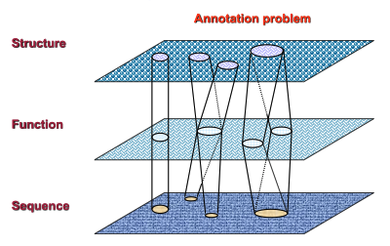

The second case is **diversity**. And the third case is seq very similar, but with different function an same structure 🡪 **paralogs.**

#### SCOP

The scop classification has been group the proteins by:

**Class**: It groups the folds according to the percentage and 3D disposition of the regular secondary structures. Have all alpha, or all beta, or a mix.

**Family**: It groups proteins clearly related by homology. In general we assume they are homologs if the alignment has >30% ID, they have the similar structure and similar function.

**Superfamily**: Proteins which sequences align with very few %ID but showing similar structural patterns and similar function.

**Fold**: Proteins with very similar disposition of the regular secondary structures

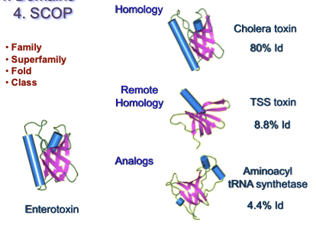

#### CATH

The classification of SCOP is manual, but there are automatic ways to do classifications which is CATH.

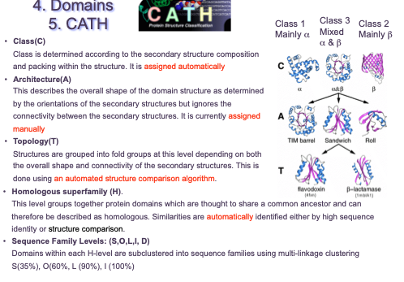

# Protein structure II

## Soluble and globular porteins

### Principles observed in folds

The structure of PDB is made by **crystallography**.

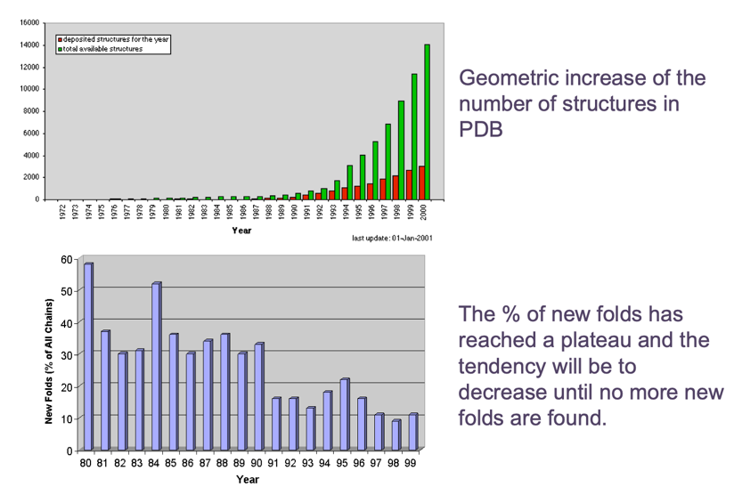

The more predicted models, the less folds are found new.

* Folds have a **compact structure** formed by the organization of regular secondary structures.
* Folds have an **hydrophobic core** that stabilizes its conformation
* The hydrophobic core is formed by non-polar residues, while polar residues are mostly in the surface and active sites (for globular proteins, for the membrane proteins works the other way around).
* Structure is conserved among proteins with similar sequence.
* The total number of folds is finite
* The structure of a protein can be built by joining several folds (this can be produced by gene fusion).

### classical folds (TIM & Rossman)

#### A diagram of a structure AI-generated content may be incorrect.TIM Barrel evolution

This structure has two hydrophobic cores, one inside the beta barrel and the other between the alpha helices. This double core makes high stabilization of the structure, and many of the structure that where available for this barrel, and different seq, so it was thought that this structure is a **classic example of analogues**.



TIM Barrel **is the most stable**.

Surrounded by alpha helices

Beta-sheet

How does the TIM barrel come from evolution?

* A **fusion gene** is a hybrid gene formed from two previously separate genes. I8t can occur as the result of translocation, interstitial deletion or chromosomal inversion.
* **Gene duplication** plays an important role in enzyme evolution. It has been estimated that 50% of all genes in microorganisms are the result of duplication events.
* **Gene duplication and fusion** events that multiply and link functional protein domains are crucial mechanisms of enzyme evolution.
* The analysis of amino acid sequences and three-dimensional structures suggested that the (αβ)8-barrel, **has evolved by the duplication, fusion, and mixing of (αβ)4-half-barrel domains**.

The original gene was half a barrel and were duplicated and fused.

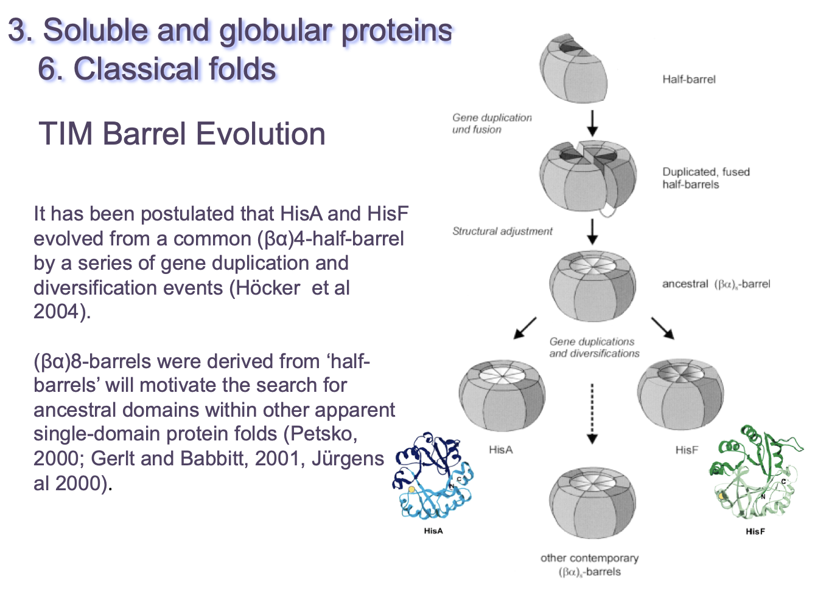

paralogs



What happen if we start to have changes before?

b. has suffered deletions

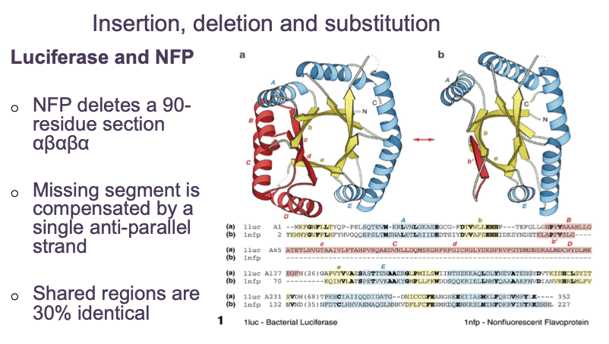

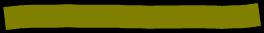

But still they are homologs, coming from a common ancestor.

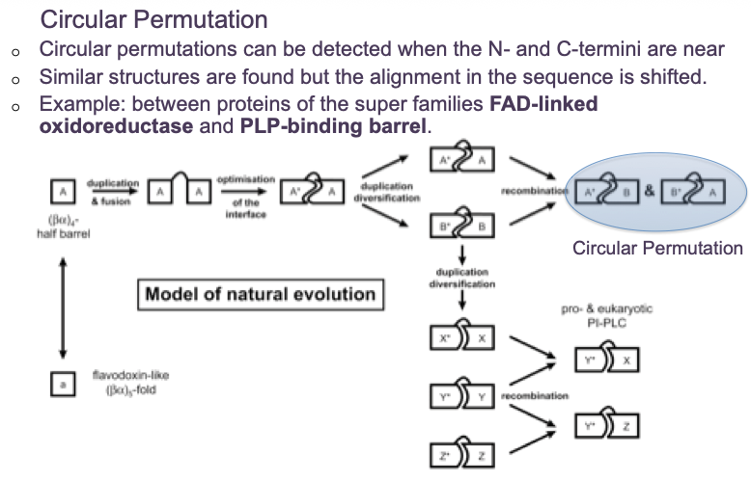\

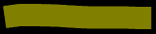

Start with a gene duplication, then a fusion, then on the fusion, we can have several changes, but then we can have a recombination, in which have of the barrel combines with the other half of the barrel, and that is very difficult to make homology, because the C-t aligns with the N-t, so it ‘s difficult to make a model like this.

Another fold would be the Rossman Fold

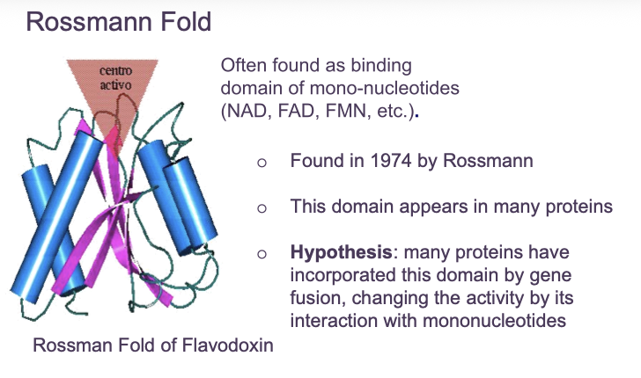

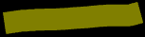

Surrounded by alpha helices on both sides, and recognised oxidoreductases or enzymes that requires NAD, FAD, etc. Also, this folds appears in many different enzymes, because transfers the transfer of ATP (for the energy usage).

* Possible to predict where the **active site** is, as it is in a β α motif of the type NADP/FAD binding loop. So is possible to predict just by the structure.
* The location of the loop was often found in the change of orientation of the topological diagram. This is named **topological switch point**. To recognize it we have to transform the 3D structure into a topological diagram, where it is represented each alpha helices and beta strands.

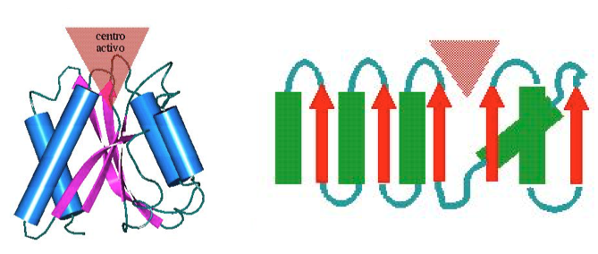

First beta-strand

Second strand

First helix

The second strand has H bonds with the first one, and then alpha helix and also the first strand has H bonds with the third strand. All 5 strands produces beta-sheet.

Once re-presented the structure in a topological diagram, we can go for the orientation. When following the sequence, in the third strand the direction change to the left, and this change of orientation in 2D is known as **topological switch point and is where occurs the active site** of these folds, so it’s just at the C-t end of the near strands where is this change of orientation.

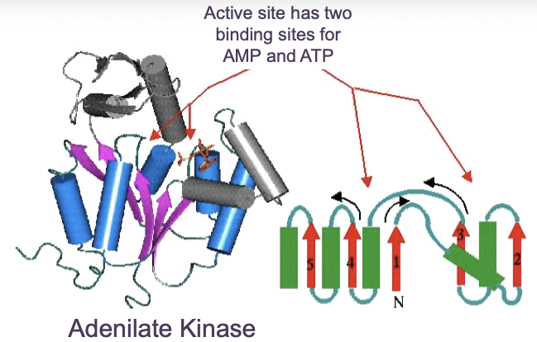Here is another example, in this case an adenylate kinase:

adenylate kinase require AMP and ATP to form ADP.

In this case we have two topological changes of orientation:

* **Between β-strand 1 and β-strand 2 (near helix 3)**
* **Between β-strand 4 and β-strand 5**

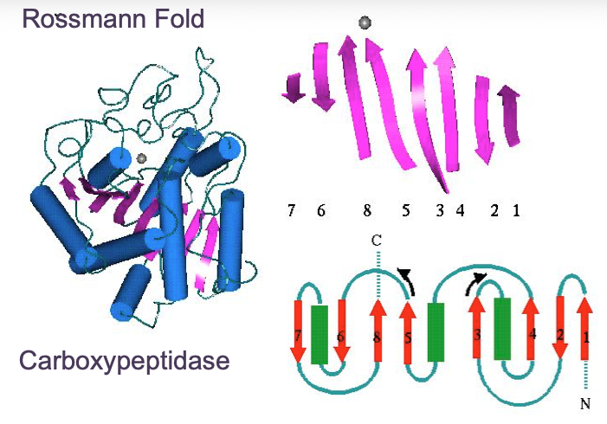

We see that the third strand goes to the right and on the fifth one goes to the left, so there’s a change of orientation.

#### All A

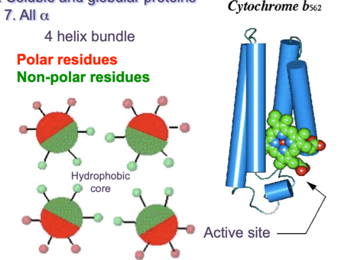All alpha helices interacting.

α-helices pack together so that **non-polar side chains face inward** and **polar side chains face outward.** The **active site** (green spheres) sits in a pocket formed by helix packing. The protein secondary structure consists only of α-helices.

• **Primary** → amino-acid sequence

• **Secondary** → α-helices, β-sheets

• **Supersecondary** → **motifs** (e.g. helix-turn-helix, β-hairpin)

• **Tertiary** → **entire folded domain**

• **Quaternary** → multiple chains

Here we have 4 secondary structure. This whole structure is already by its self a structure, so we do not need additional structure to it, is a single fold, eventhough by the number of secondary structure we could say it is a super-secondary structures.

A **supersecondary structure (motif)** is usually:

* Small
* Repeating
* Part of a larger fold

Examples:

* Helix-turn-helix
* β-α-β motif

A **4-helix bundle**:

* Is **already a complete fold**
* Can function independently
* Does **not require additional elements**

#### All B

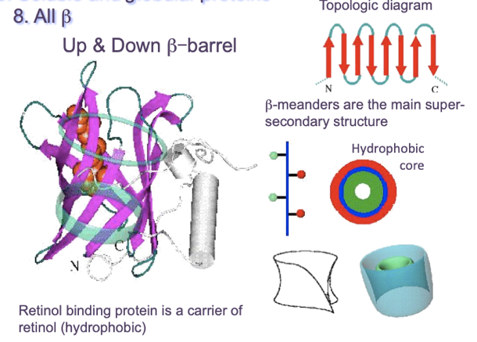Starting with a beta-meander.

We have many different hairpins all together. One of the faces is hydrophobic and hydrophilic. The lasty strand of the beta-meander will have H bonds with the first one, and at the end it closes like a barrel. At the end it will form a hydrophobic core inside and the hydrophilic is looking outside.

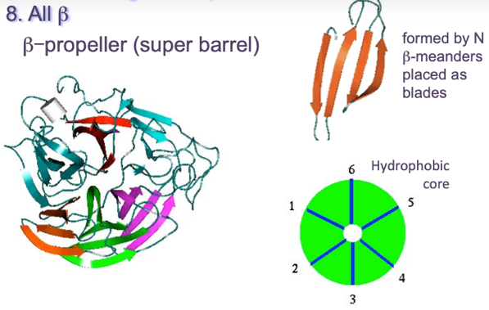

Continuing with beta-meander structures, in this case, this beta-meander is formed by 4 strands. Both sides will have hydrophobic properties. At the end, somehow it will need to be closed, and that will be done in a barrel. The hydrophilic part is “a les cantonades”. That’s why is called a propeller (helice).

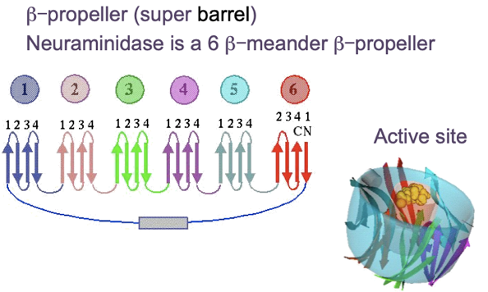

This case is a beta-meander and a beta-propeller. Here we have the different meanders.

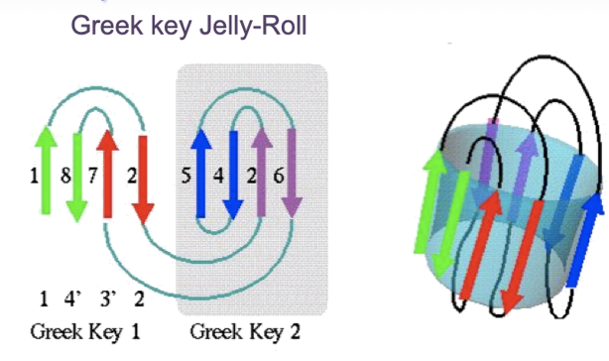

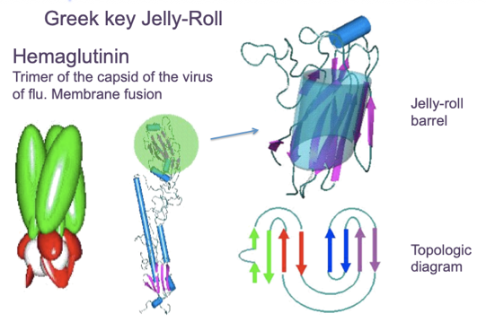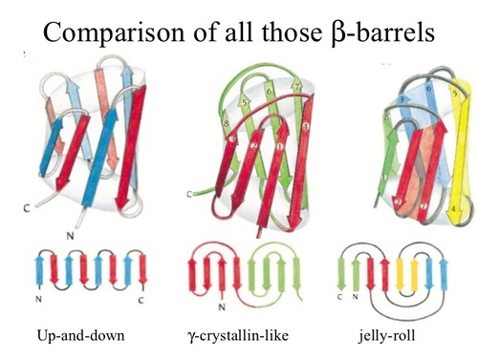The construction of this is a long beta strand forming a hairpin (a very large) and this is unstable, loosing some H bonds. The **first beta-strand (green) makes H bonds with the last one** (the other green arrow), and so on and so forth for the rest of the arrows. The resulting construct will form a jelly-row. Comparing to beta-barrel, the jelly-barrel has loops at the top of the barrel, while the beta-barrel not



A perfect example of a jelly-roll is hemaglutinin:

Also glucanase

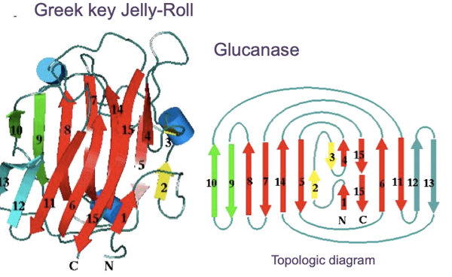

Another classical beta-folds is the beta-sandwich, the **immunoglobulin-like fold**.

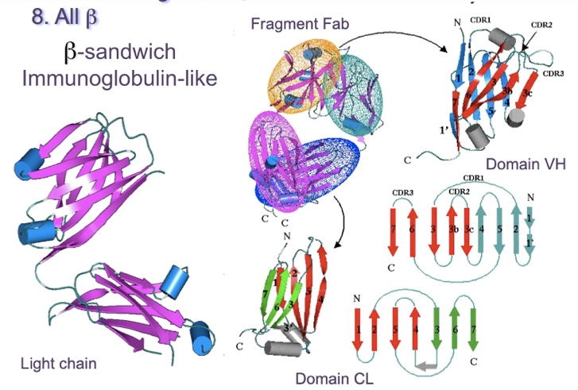Is one Greek-key, and by the hydrophobic faces makes interactions with another Greek-key.

Antigen recognition

The loops are the CDRs, the complementary determining regions.

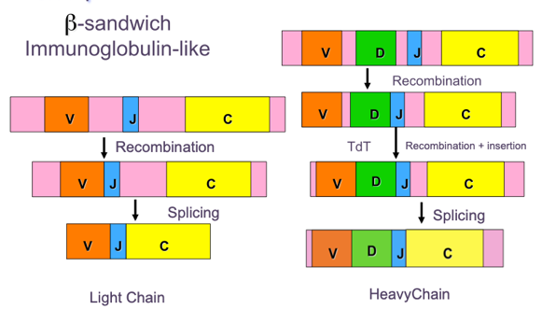In the antibody we have two light chains and two heavy chains. In the light chain, by recombinations and splicing it is formed the light chain. In the heavy chain there’s n extra region called D, and there’re steps of recombination and insertions before splicing, so this insertion gives more variability.

#### A diagram of a barrel AI-generated content may be incorrect.A/B

Super secondary structures produced by one beta, one alpha and one beta. We have already seen that in TIM barrel the beta strands have both faces hydrophobic, so there’s a double core. The TIM barrel will be surrounded by alpha helices. In this case all are right alpha-beta repeatedly.

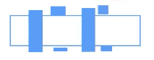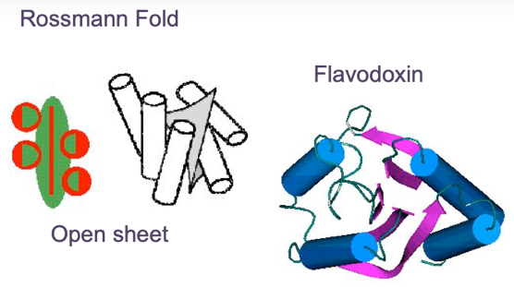

What happen if we combing right and left alpha beta?

The Rossman fold is an open sheet surrounded by alpha helices.

#### A+B

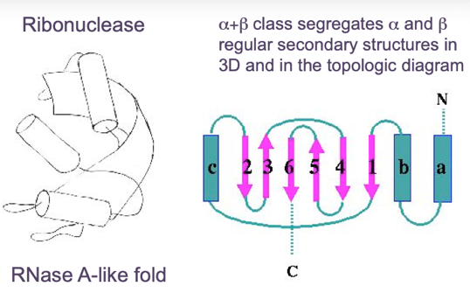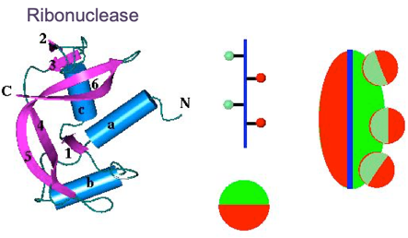

The beta strand and alpha helices are split, are in different regions. The hydrophobic side is closed by the hydrophobic part of the amphipathic alpha helices.

## Globular membrane proteins

### Definition

* Membrane proteins are protons bound to the membrane
* Can be two types:
  + **Peripheral:** are only linked by few residues to the membrane
  + **Integral**: are inserted in the membrane, where he main bulk of domain is buried inside the membrane
    - The **residues** of the integral proteins are **mostly non-polar**, changing the rules of hydrophobicity patterns described for soluble domains.

### Classification

#### Integral

There are only two main types, those that are constructed by alpha and beta strands.

* Alpha helices 🡪 **alpha helix transmembrane**: helices cross through the membrane, and the helices are almost completely hydrophobic. Some of the loops that link the alpha helices are outside, so they need to be hydrophilic.
* Berta-sheet 🡪 beta strands transmembrane: typical of porins. One the side of the lipid membrane are hydrophobic and the hydrophilic side (polar residues) is in the interior of the strand making a whole where several compound can cross inside the membrane.

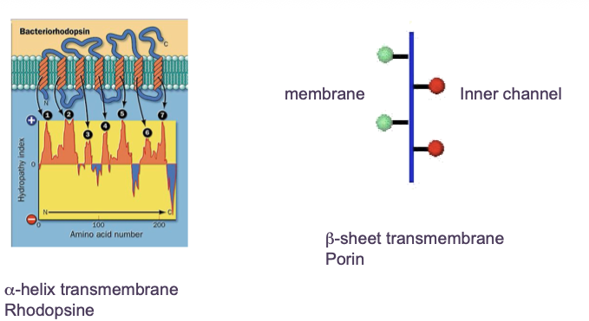In the beta transmembrane the membrane part is hydrophilic and the part forming the channel is hydrophilic. But in the alpha transmembrane, the whole alpha helices are hydrophobic. By looking at the plot we would recognize what kind of secondary structure of membrane proteins.

#### Peripheral

Only linked to the membrane and there are many ways to link them:

* Interaction by an **amphipathic helix** parallel to the membrane plane (the alpha helix have hydrophobicity propertiues)
* Interaction by a **hydrophobic loop**
* Interaction by a **covalently bound membrane lipid** (lipidation) (link them with fatty acids)
* Electrostatic or **ionic interaction** with membrane lipids (interaction with the negative charges of the lipid membrane, mostly the phosphates)
* **Hydrophobic helix transmembrane** (a full hydrophobic transmembrane helix)

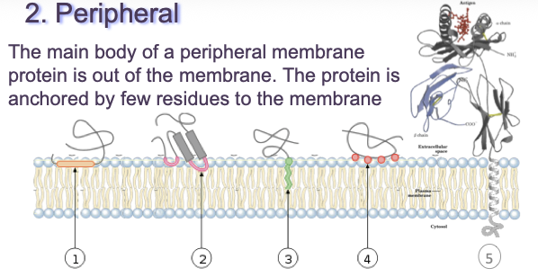

The next lecture will be experimental methods to recognize the structure of proteins.

# Homology model

## Basic concepts of Homology Modeling

Extrapolation of the structure of a new (target) sequence from the known 3D-structures of related family members (templates)

The **number of different protein folds is limited**.

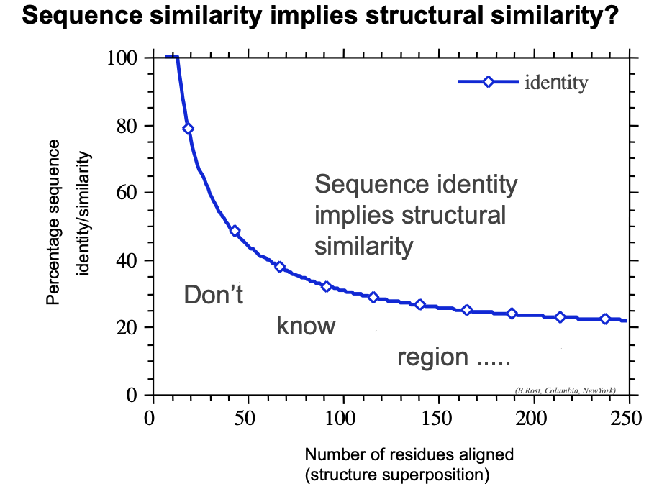



This are is those who have same structure

Twistlight zone

Curve of zone. Imagine we superimpose the structures, and once they are aligned, calculate how many residues are aligned. In this plot, shows the total residues. If we have 50 residues that ar superimposed, we should have more than 40% identical residues. Instead of the structural alignment, we do seq alignment, we have the same. So, that gives us an idea of how to model it.

* Folds is more conserved than seq
* Secondary structure are the most conserved parts
* Loops have the higher variability in structure

We still have seq with no info, or very scares info or enough info. The main objective in the homology model helps but in the case of having no information, NO!.

## Schema of the method

If we have a sequence, by using BLAST, HMMER, and with just a seq, I may say that this is a globin fold for instance. The next part, is to find the best sequence fold of the model.

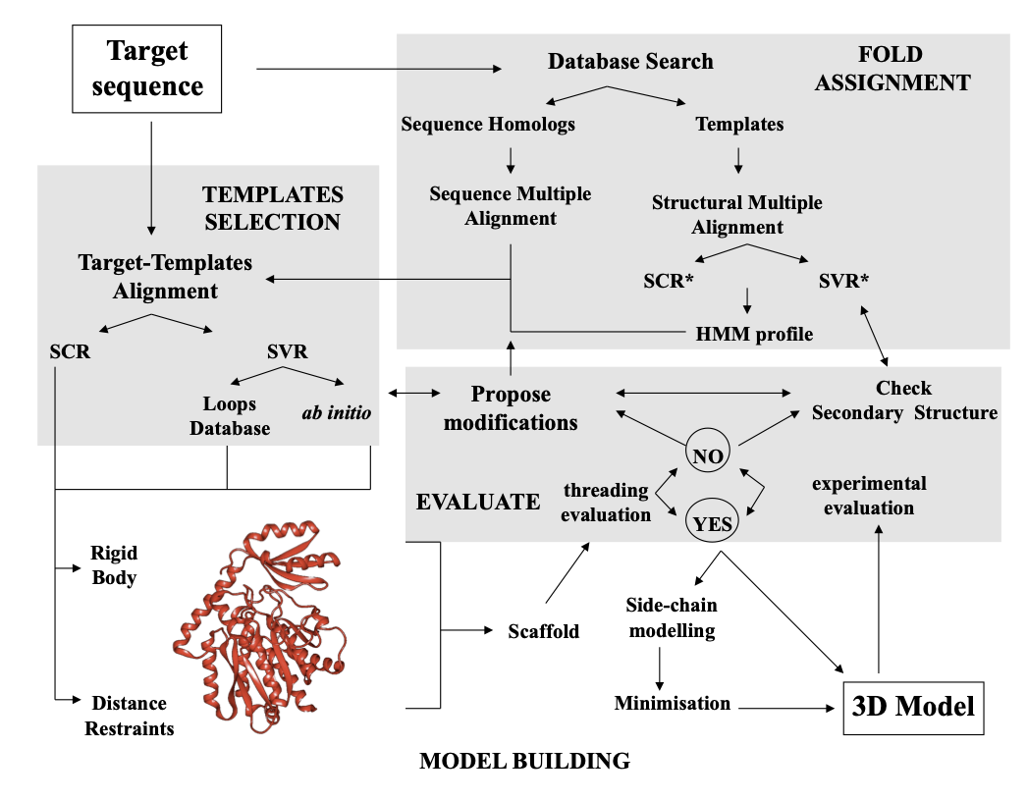

### Fold assignment

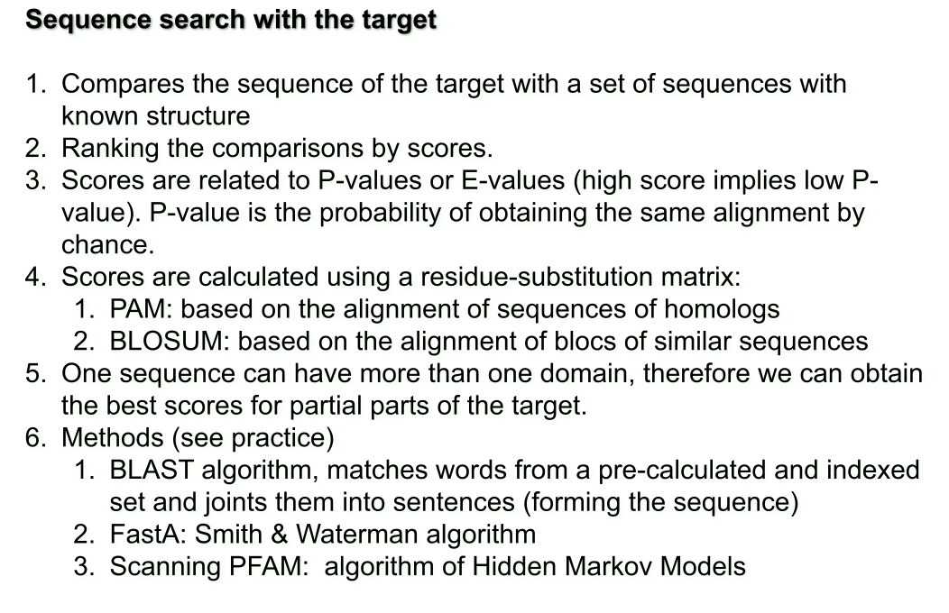Use programs such as BLAST, HMMER, search the db and find matching seq. Once we have those, seq that are homolgos, we will also recognize possible templates and with them we can align them and se the more conserved regions.

If we align structures (MSA), we can extract the info of this alignment, saying which residues are going to be conserved, so we a HMM can characterize this profile.

### Template selection

If this is the space of sequence, and in the extremes are the homologs, from the whole set of homologs, we will use the closest. The thing is, sometimes with the closest one, there are som missing parts, and go for the other homologs. What we cannot do is take the further away, because the firhter, the more changes in evolution, so try to not start with the wrong template. SCR is structural conserved regions.

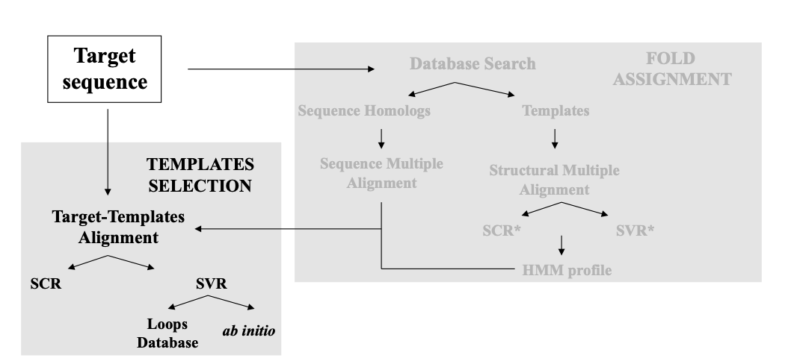

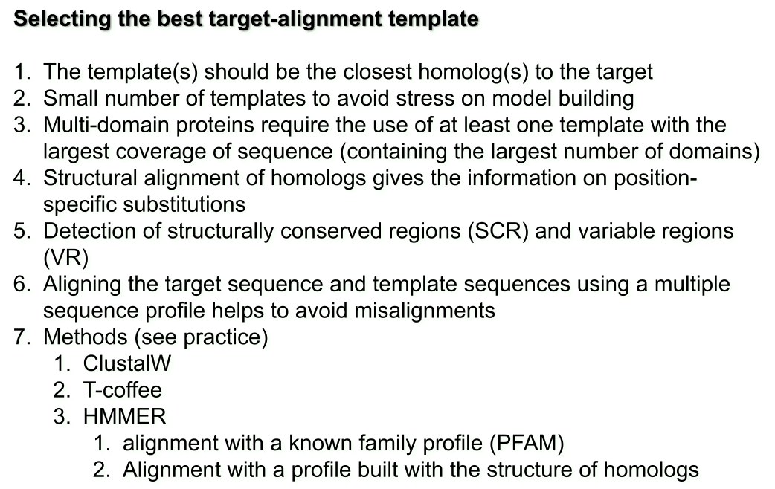

#### Example

We have two templates, and both are close enough, so use any of both. See regions which one template does not have info and the other yes, and another region happens the other way around. For us, this are variable features, change among the seq. Now if we want to make the whole model, we need to use both models. When looking for the closest homolg, what happen now if the protein has two domains? And both templates only have one different. The only way to place it is using another template

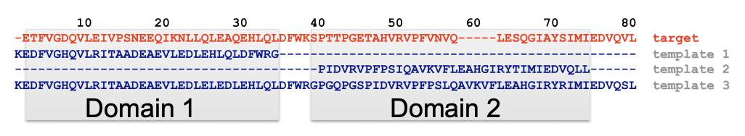

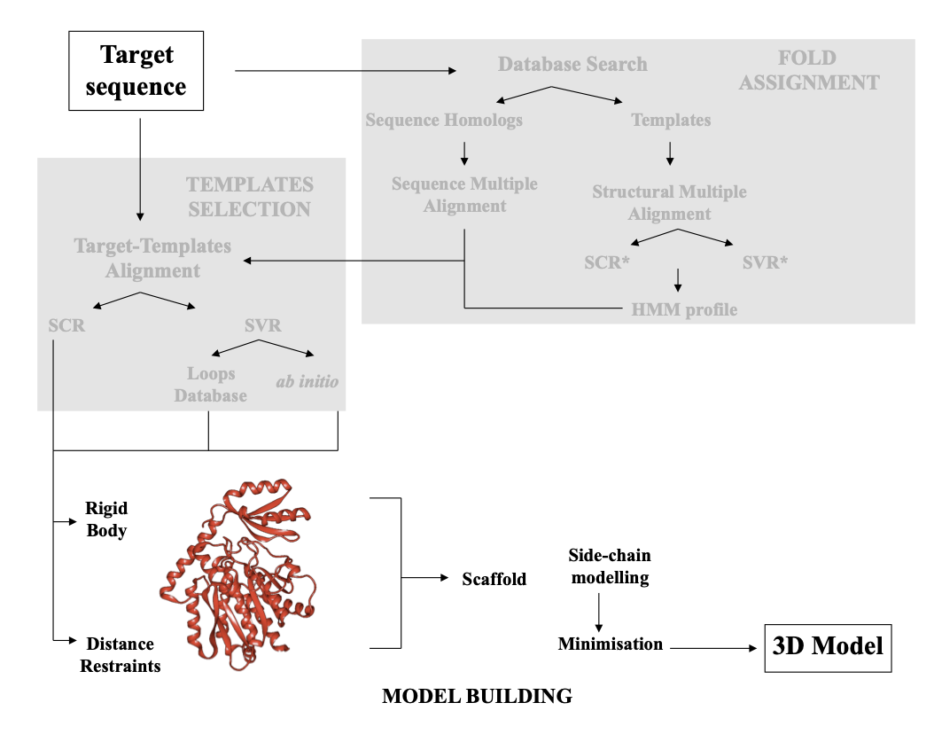

### Model building

It is an algorithm

#### Rigid body assmebly

##### Core framework and loop modeling

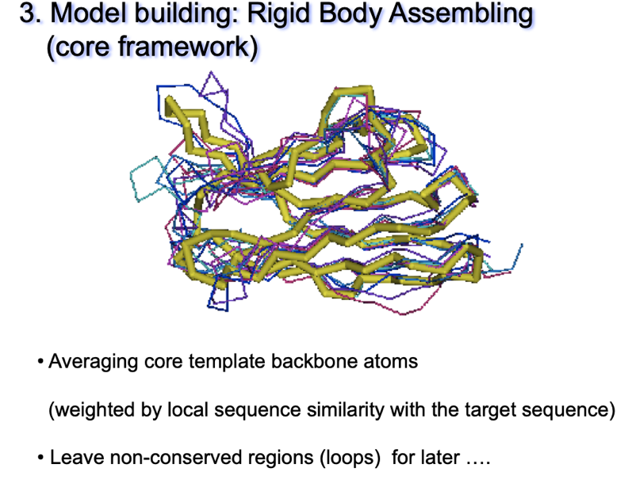

Construct the most conserved regions, but not the variable, because might have different conformations.



So, how to place the loop, and for that there are two ways:

* Use the “spare part” algorithm to find compatible fragments in a Loop-database
  + 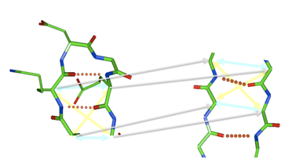
  + Check for the distances between the CA (alpha carbon), because the distance are similar, superimpose.
  + But this match is not exact, is impossible, and because of that, the complete structure, the distances between CA, carboniles, position of the charges is not the best. For that we need to optimize
* Ab-initio” rebuilding of loops (Monte Carlo, molecular dynamics, genetic algorithms, etc.)

##### Energy minimization

To optimize the complete structure, in other words, optimize the energy. We want to find the minimum:

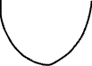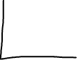

X i + 1 = Xi + last position

|X i+1 – xi | < Energy

The derivate explains this. (dt/dx, dt/dy) is the radius

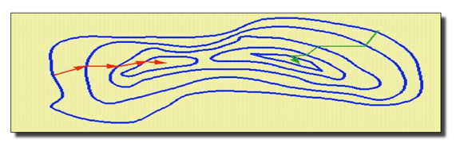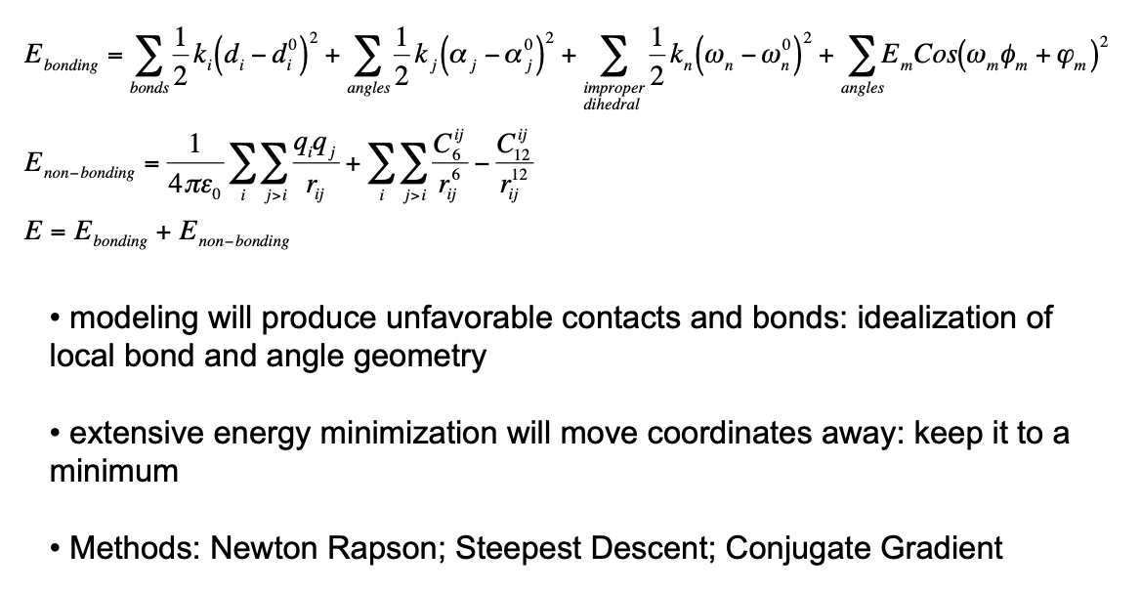



The derivative 🡪 newton Rapson

Conjugant gradient 🡪 takes the gradient

So if we have the beta-strands and then the loop, if we have to change completely, like one beta has to be changed for an alpha, forget about this methods, this won’t work, only workds for slightly changes.

#### A close-up of a diagram AI-generated content may be incorrect.Spatial restraints

The Ramachandran Plot takes de angles pf phy and psi in angle structure Now there are certain angles, that are very special. From PDB structure, we can transform them into this distribution of energies.

How can we derive modelling restraints from this data?

Volsman function says:

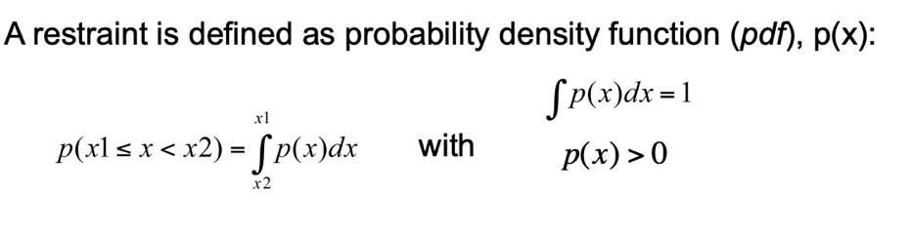

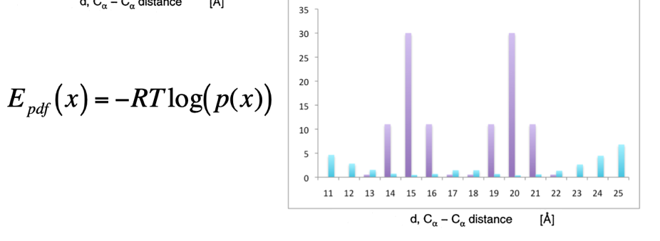

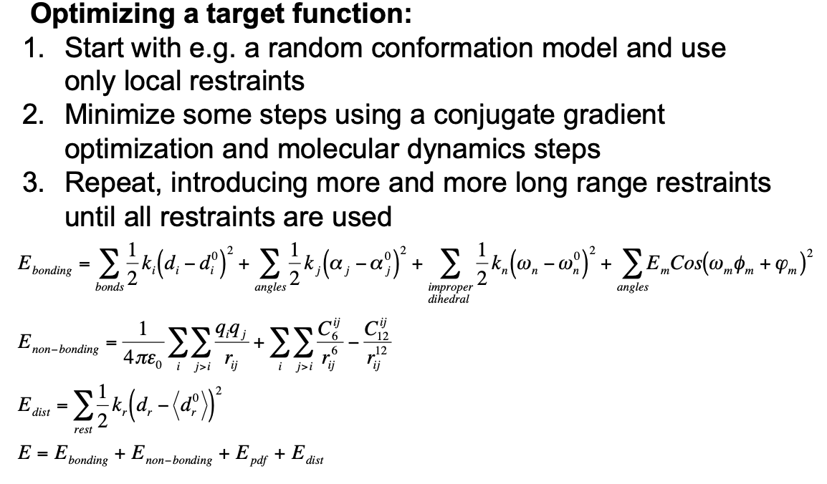We need to extract info from the templates. Once we have the alignment, we go to the template and check the distance between residue, and because they are conserved, this distances should be closer. So, my target, my seq is about d1 & d2 distances. So if we have many templates, more distance variability and the model has to apply too many variability then.

By applying this distances, the system should fold. If the energy is too high, it takes so much time to get the final structure. To solve this, we have to make molecular annealing, and has to do something with molecular dynamics.

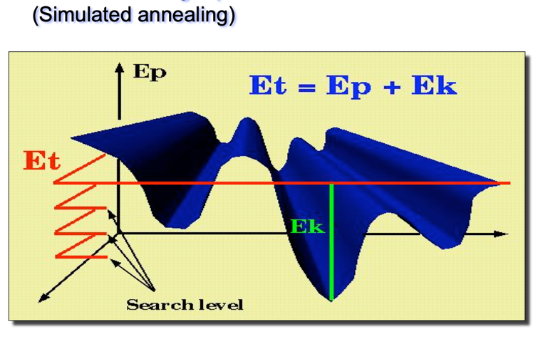

If we have to cross that “valle” we need to increase the temperature.

Total energy (kinetic energy + potential energy)

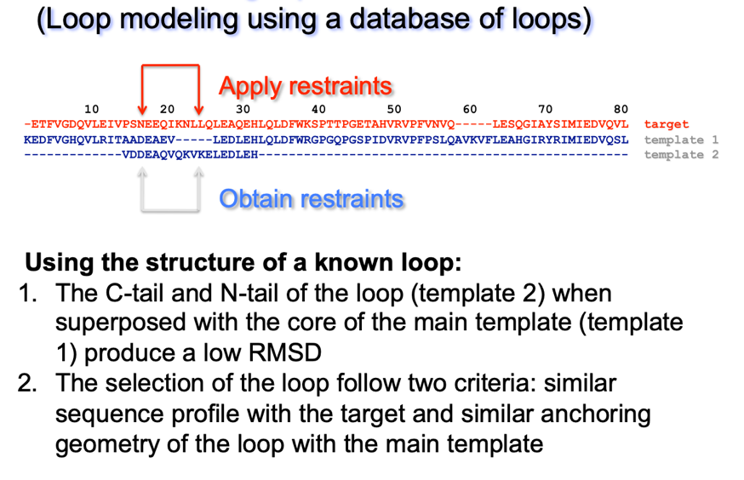Total energy is constant. So when we find a pick we should increase the total energy to cross, but this is constant. The reasoning is because there the potential energy is higher, and that is impossible. For that, we should increase the kinetic energy.

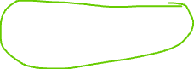

The loop is moving freely, because there’s no restriction, there’s no seq maching. For instance, the loops binds to GPT, but I don’t know it’s structure, so by estabilishing the distance, I can reproduce it.

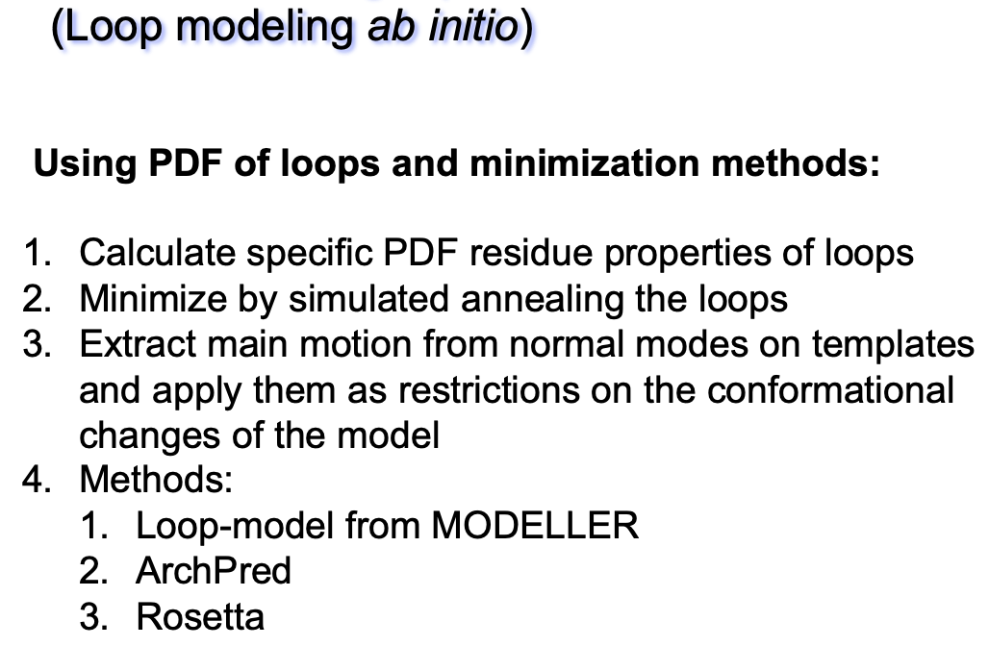

#### A math equations and formulas AI-generated content may be incorrect.Side-chain modeling

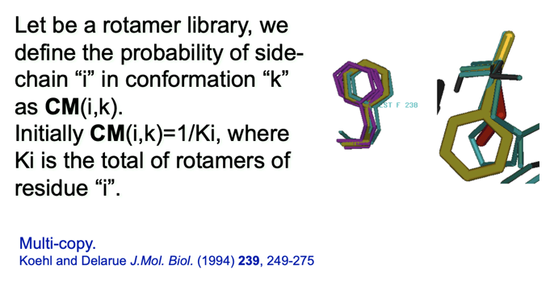

The main chain is fixed, and the density probability of the whole space of the main chian is this:

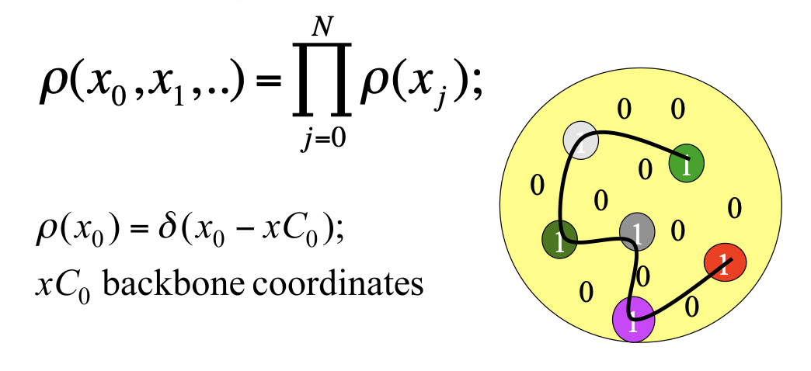

If the coordinates exist, hs a value of 1 if not, 0. The only way to get a value of 1, is each atom of the main chain matches.

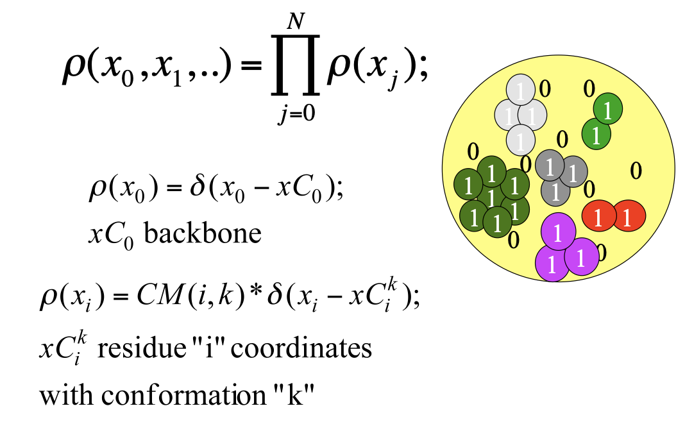

Every time we have a side chain, we have more than one solution. Probability of the density of the side chains.

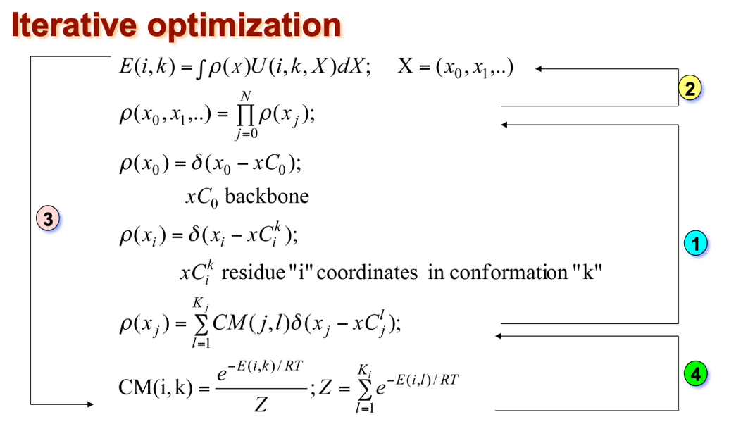

For the core of the protein is fine, but for the surface of the protein is not. Finally, we have to check if a model is right or wrong, so evlautate the model to take a decision.

### Evaluation

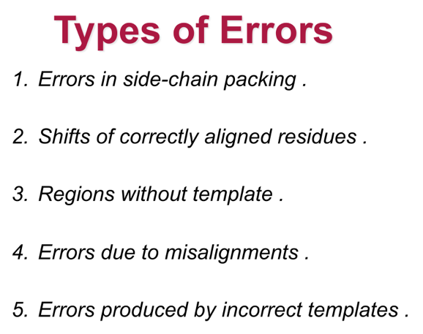

If we don’t have a template, we let the system to move freely. The worst is the errors produced by incorrect templates, because you have to start again.

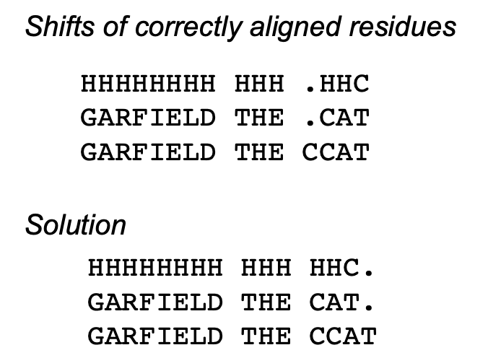

I have made an insertion, we have broken the helix structure, and highly unstable. Changing the alignment, energetically is better.

An alpha helix needs 4 residues to make a turn, so in the two first you broke the alpha helix structures, and it is not energetic favourable.

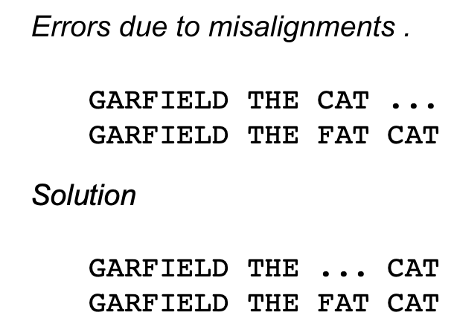

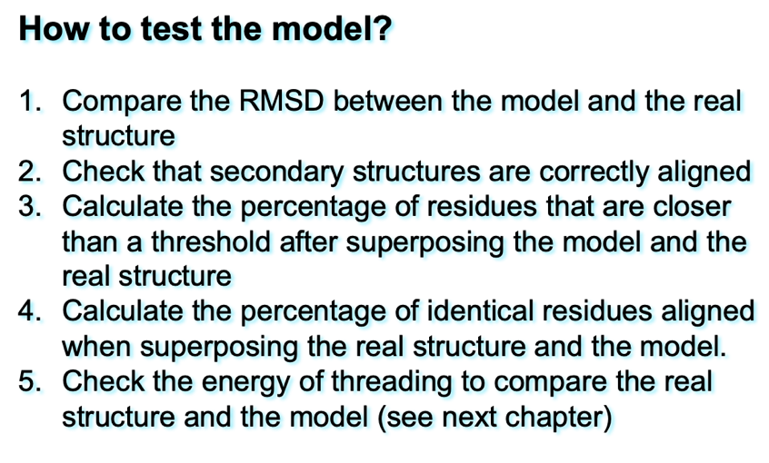HMM this would happen. Apply GAP penalty, HMM cares for the position, and t-coffee.

### Imrpovement

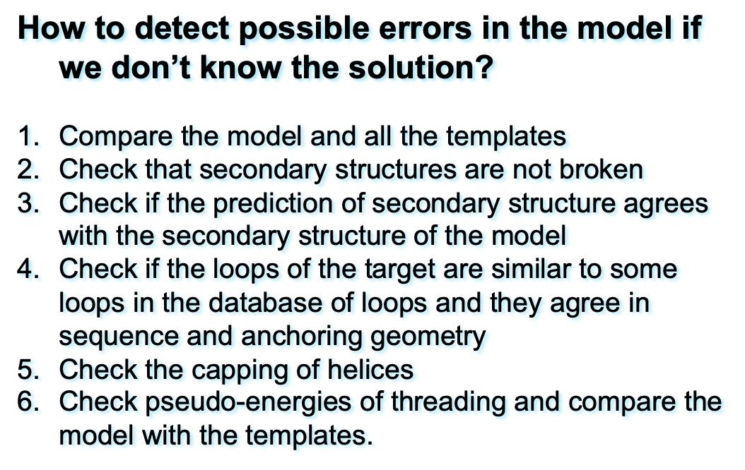

Apply for structures ab initio.

To chek all the loops and what kind of variability in all the template:

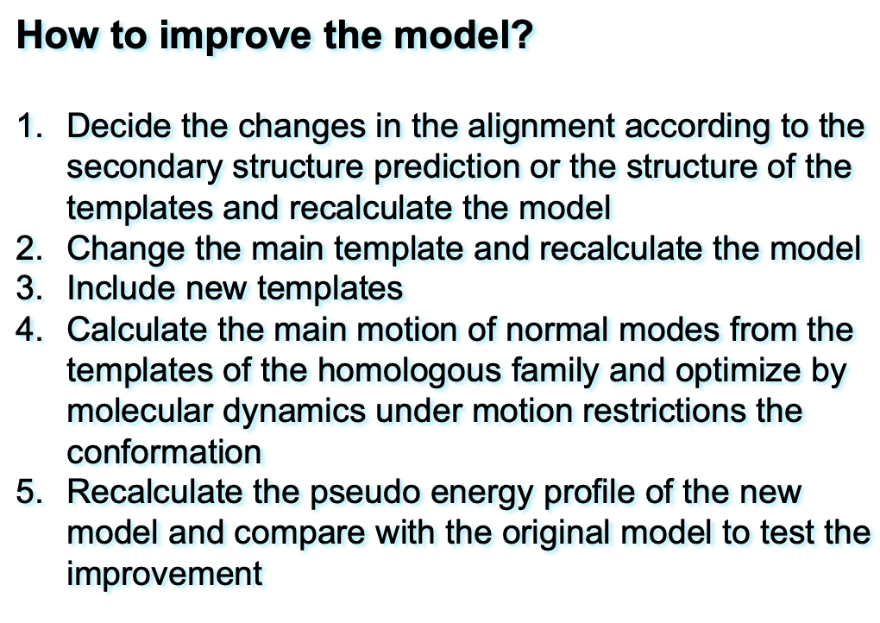

## Example

Pro-carboxipeptidase has a pro seq, and with another enzyme will do a cleavage, realeasing the activation segment. Pro-carboxipeptidase a is slower than b

I want to model pro-carboxipeptidase human A2, and I have this:

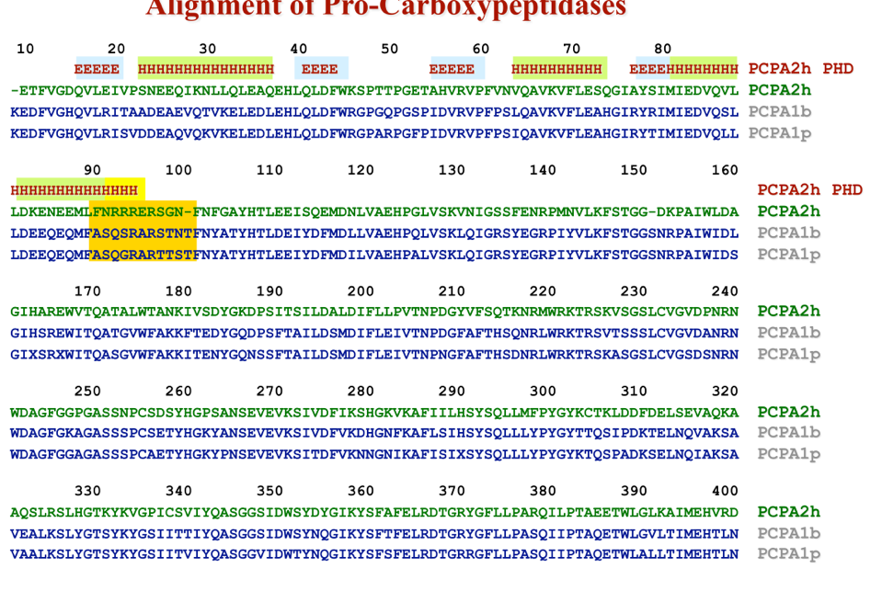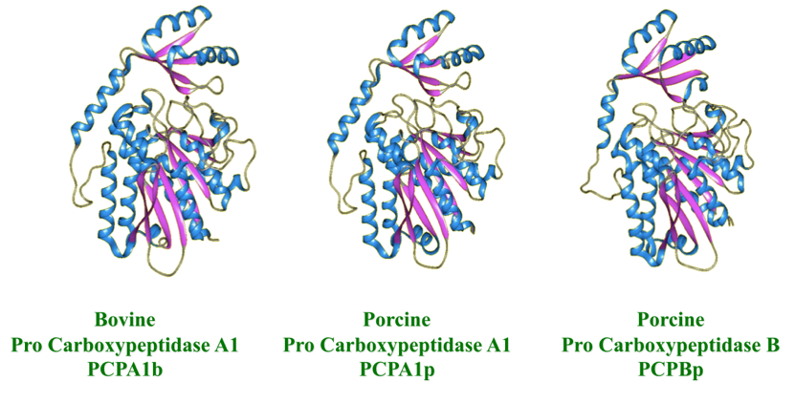

If we want to choose one, better pick the A version. Do the alignment

In yellow is the actual alignment and in green is my prediction.

A deep further in this region:

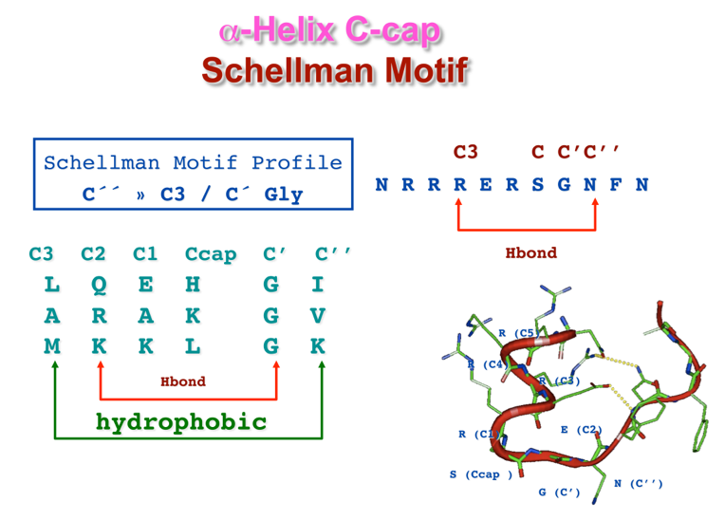

It will stbailize, because its charges are positive and if they are located in the C-t (which is -), forms a netrualized dipol.

By adding just one helix to the template. In red Is the actual structure, and in green is the modelled. If we use **pseudoenergies**, we can check this problematic region.

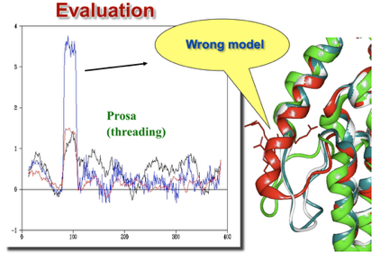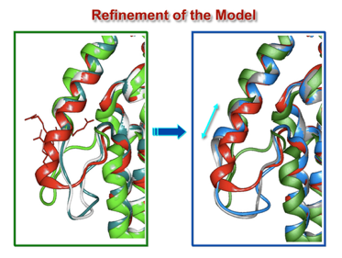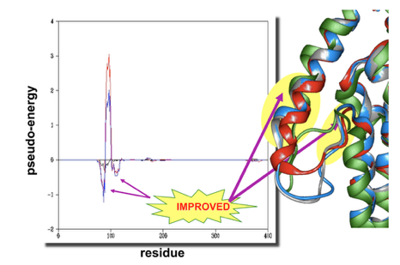

Just taking the residues and recalculating the model, we can check on the energy.

# Exercise SBI 3P: Structural similarity. Protein superimposition and structural alignments using chimera and STAMP

Download SBI6 material and will download the P_Stamp folder.

* + - 1. Superimpose the structures:
         1. Pdb1lh1.ent

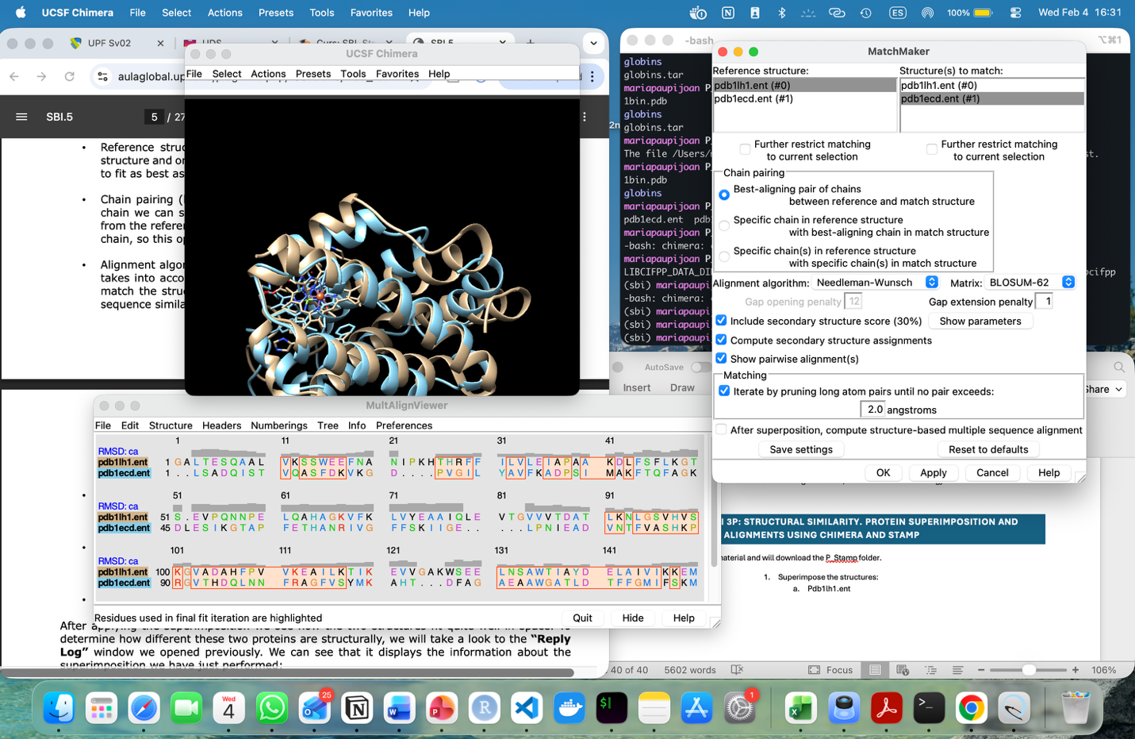

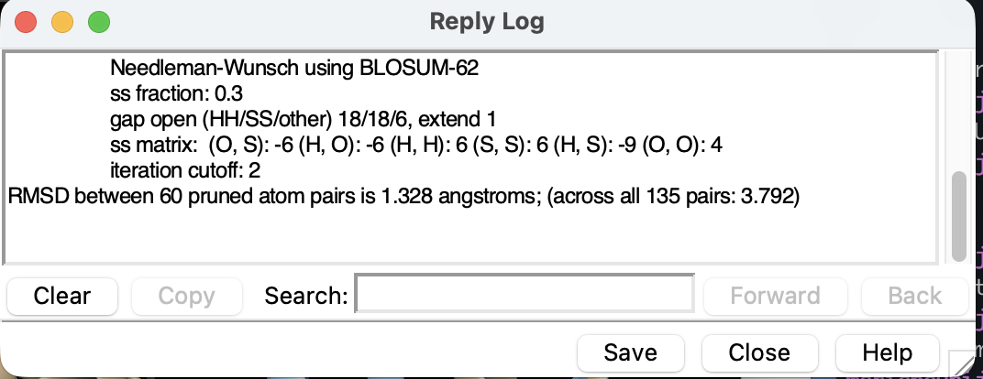

The RMSD is around 1.3nfstroms and it depends on the len, but it is said htat a good rmsd has to be lower than 3 angstroms to be considered good.

# Fold prediction

Construction of proteins when have no info about the templates. For a very long time, there was a time to obtain protein structures was a struggle. The idea of knowing the structure just by seq is very classic. For that, there are several approaches, for instance: fold recognition.

The total number of folds is limited, so when there’s a new protein, we check if the fold is known, is the number of new folds drops down, compared to the new structures is increasing. To see if a protein has a certain fold, it is called fold recognition. To do so, is by threading, calculate some kind of scores (energy) to see if the sequence fits nice.

However, what if the fold is new? That means constructing ab initio folds. And there’s a third question, what if we want to know the folding? How it has fold, how this fold has made.

The speed of rotation of this peptide bonds (phy and psi) is super-fast, femtosecond If we count the number of possibility (360 degrees) to the power of n being n the total number of residues the seq has, if we calculate is this and calculate by the number of femtoseconds, it would lead to months or years, and that’s impossible, because a protein folds in seconds.

There have been approaches of how the fold of small peptides computationally work. Large number of other methods like molecular simulation to speed up the folding but not go for that.

Will only focus on fold recognition (and the tools to study it), ab initio fold prediction and protein folding.

## 6.1. Fold reocgnition (threading)

Find the optimal structure for a new (target) sequence in the set of known 3D-structure (templates) by threading the target sequence. As proteins have hydrophobic interactions, we have to include the entropy, water molecules, and we cannot do it. We need something else,

### 6.1.1. Knowledge-base potentials

Connection between energies and probabilities. The Boltzmann equation links energy to probability. But I want energies based on probabilities, so I will do the inverse of the Boltzmaan law.

PDB calculates how many times Arg-Glu. Arg has + charges and Glu has – charges, and calculate how many times I see this (probabilities goes in the y axis).

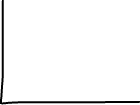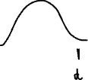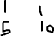

What happen if I have Arg (+) and Lys (+), and frequencies tells how much this two aa goes together, so that means, in a potential energy, we will have minimums, minimum between interactions wih arg-glu and arg-lys.

If I measure the tienractions 🡪 calculate diastances 🡪 energies (higher or not)

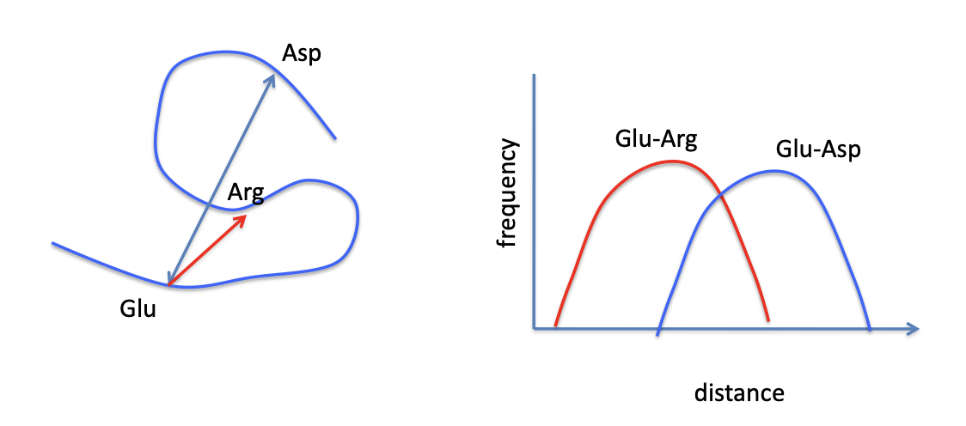

#### 6.1.1.1. Distance dependent potentials

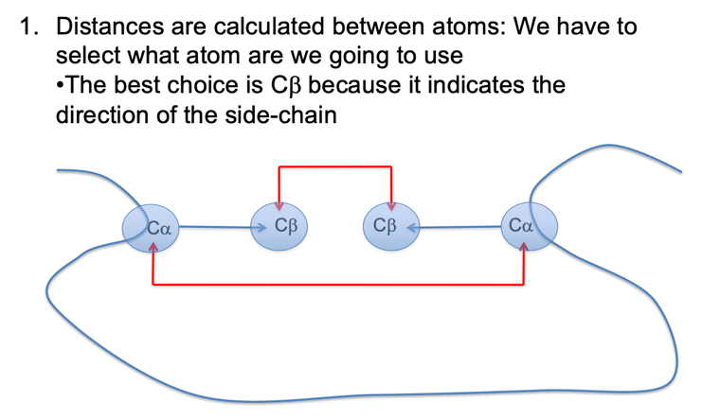We can calculate the distance between two atoms, but not with two aa.



The CA is not enough if they interact or not, we have to say where is the side chain, so have to calculate between so many atoms, apart form gly (has Cbeta)

* 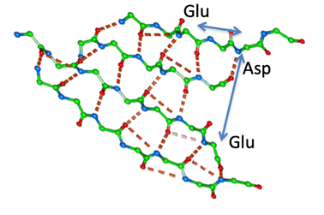Atom-centered: If I take the PDB as it is, there are so many globins (first structures that where crystalized), lisozimes, etc. So we cannot use the pdb as it is to calculate these frequencies. So to clean this data, is remove all those cases that are exactly he same (same structure), so seq that have >40% are being removed.
* Sequence distance: The frequency of a pari of residues at distance “r” is different if the residues are close or distant along the sequence.
* Reference state: Not the same residue if it is in the core or outside the structure, so where is my reference? There are many possibilities, and one of them is if the distance between 5A you see this two interactions. Is the number of two interactions seen in a particular distance.

This is an example, calculate plot of energy , and we see a minimum for the interaction between Glu-Arg, and we ACABAR!”!!!!!!

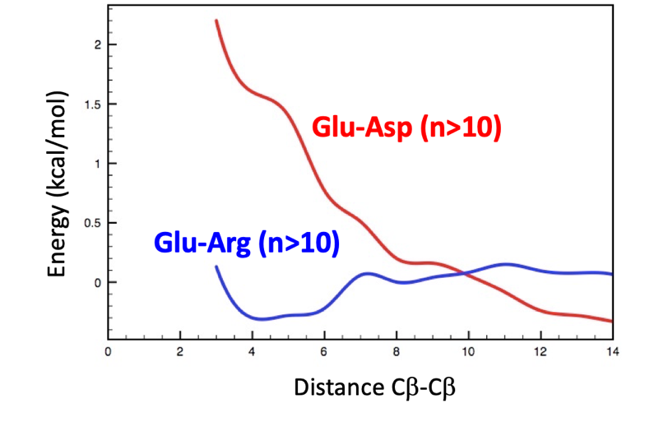

The graph compares two pairs of amino acids and plots their Energy (y-axis) against the Distance between their atoms (x-axis). In thermodynamics, lower energy = more stable/favorable.

1. Glu-Arg (Glutamic Acid & Arginine) - The Blue Line

* The Chemistry: Glutamic acid is negatively charged, and Arginine is positively charged.
* The Graph: Notice the deep "dip" in the blue line at around 4 Angstroms ().
* The Meaning: Because opposites attract, they love to be close together. The "knowledge-base" shows they are frequently found at this distance in nature, so the potential energy is calculated as very low (stable) there.

2. Glu-Asp (Glutamic Acid & Aspartic Acid) - The Red Line

* The Chemistry: Both are negatively charged.
* The Graph: The red line stays very high when the distance is small (under 6 ).
* The Meaning: Like charges repel. They hate being close to each other. In known protein structures, they are rarely found this close, so the system assigns a "high energy penalty" to that configuration.
* CB-CB Distance: This is just the measurement between the "side chain" carbon atoms of the two amino acids.
* n > 10 : This usually refers to the sequence separation. It means these two amino acids are at least 10 positions apart in the primary protein chain, ensuring that their proximity is due to the protein folding together, not just because they are neighbors in a row.

#### 6.1.1.2. Solvation

Solvent is H20, always globular proteins.

Different approaches:

- Solvation effect: proportional to the accessible space and depends on the residue. This energy is – if it is a polar residue, and if it is a hydrophobic residue changes its sign. So it is a parameter to calculate how good is the interaction with the solvent.

-

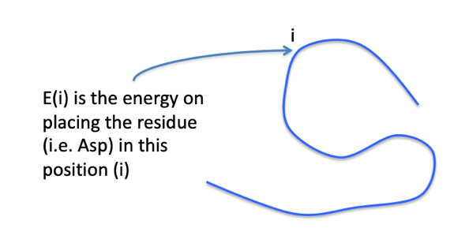

#### 6.1.1.3. Z-scores and energy profiles

Once we have a set of energies for pairs of residues (force field) we can calculate the energy of each residue along the sequence in a specific conformation.

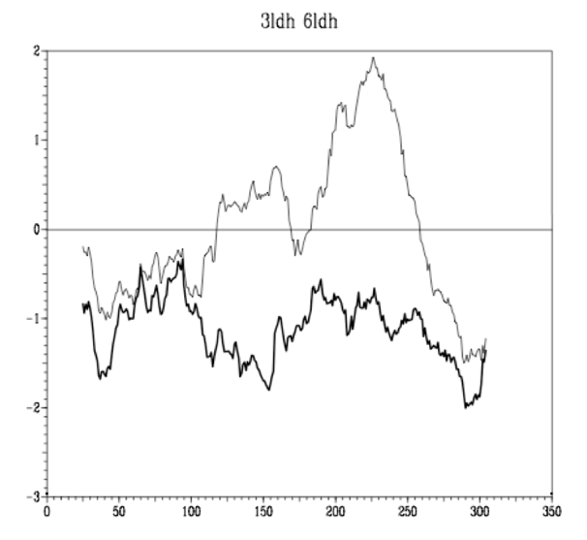The total energy (total scaffold of the protein) is the sum of the pair-energies and the energy from tis surface (solvation). The profile energy is obtained by the curves of pair-energies, surface energy and combined energy or both with respect to the residue position.

Just by looking at this plot, thinking on terms of frequencies, the lower energy, the more frequent.

X-axis (residue number), Y-axis (Energy).

We have to **smooth the curve**, and to do so, we do an average (20-30 residues) and mode the window just by one residue.

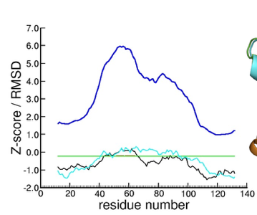RMSD (for each one of the residue) is when comparing structure, so compare one decoy and native structure. When the decoy is very different form he native structure, the RMSD is higher. So if we apply this method, if this model is right or wrong. Higher the RMSD more different the decoy and the native.

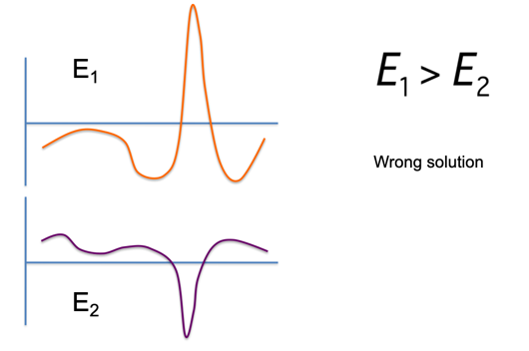I fa residue has super high energy, and the rest are ok, that typically happens in the active site, and thanks to the interaction with the ligand, it gets stabilized, thus reducing the energy.

I have now E1 and E2 and the E1 > E2, can we use the total energy to discriminate correct folds among wrong conformations (decoys)? Threat the energy into one structure and cannot change the energy.

Better check the profile. I have more than one solution and all of the have lower energy.

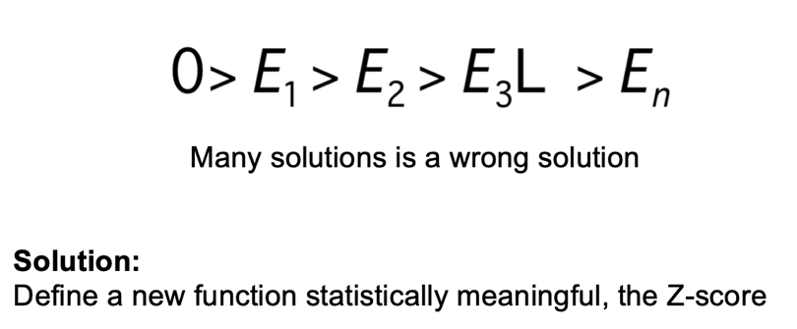

Have to **normalize** the data. And the classical way to do so, is with Z-score, compare to the average / sd.dv.

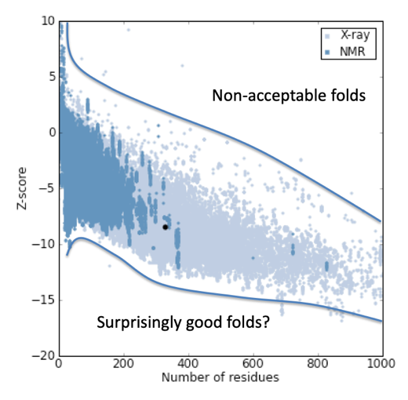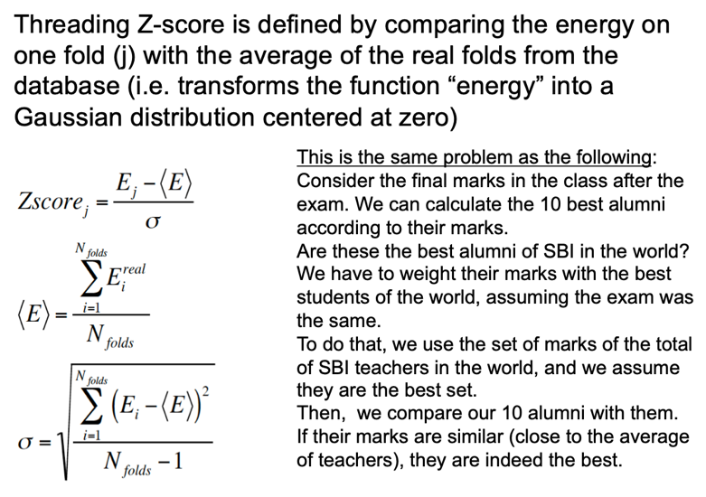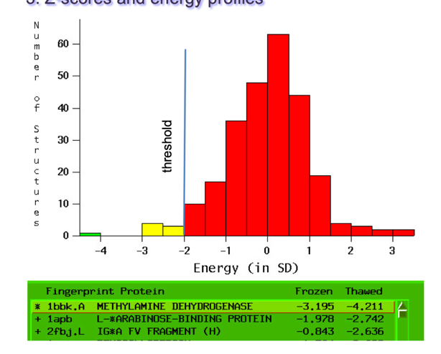

There’s a final dependence which is the size, because the size of the protein matters. If we plot the Z-scores (the ones that have been normalized) with the PDB structures, the plot looks like this. The more blue is minimizes structures, and the blueish have been crystalized.



#### 6.1.1.4. Methods: Prosa, Anolea, DOPE

DOPE is based on statistical potentials.

### 6.1.2. Distance homology matrices (PSSM)

To identity some potential remote homologs, and whith them assign the same structure.

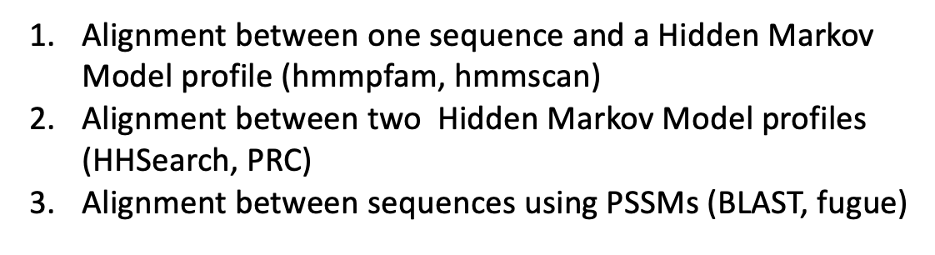

I have my protein, and when run simple blast In uniport, my protein aligns very well with kinases, and with psiblast I found some remote homologs that are serine proteases, and then I find a kinase. And I have to choose between them. If I find in uniport that the most similar function is a kinase, choose the similar function. In other words, when looking at remote homologs (share same function), and look a the PDB find nothing, so use psi-blast, and first go to uniprot to obtain a PSSM and then to PDB, and in the ranking list in top is serine, but when running in uniport, tells that is kinases.

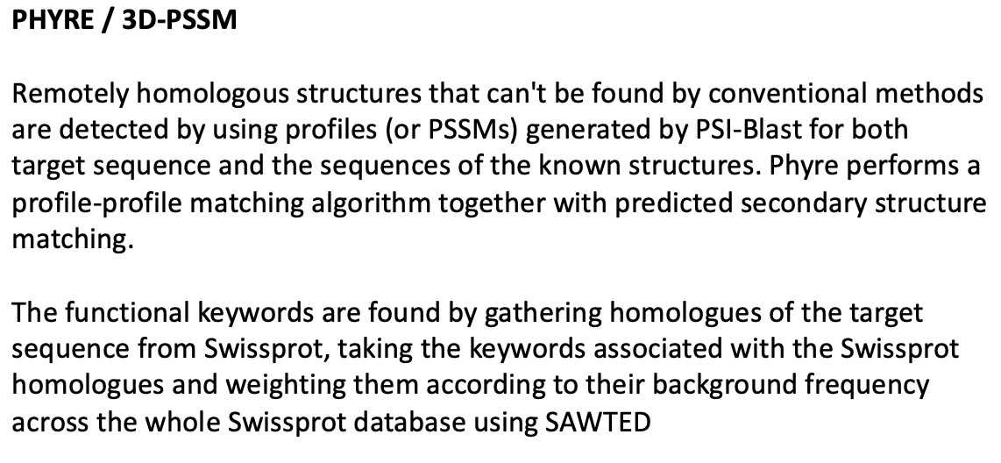

How can I translate this into a program? **SAWTED**

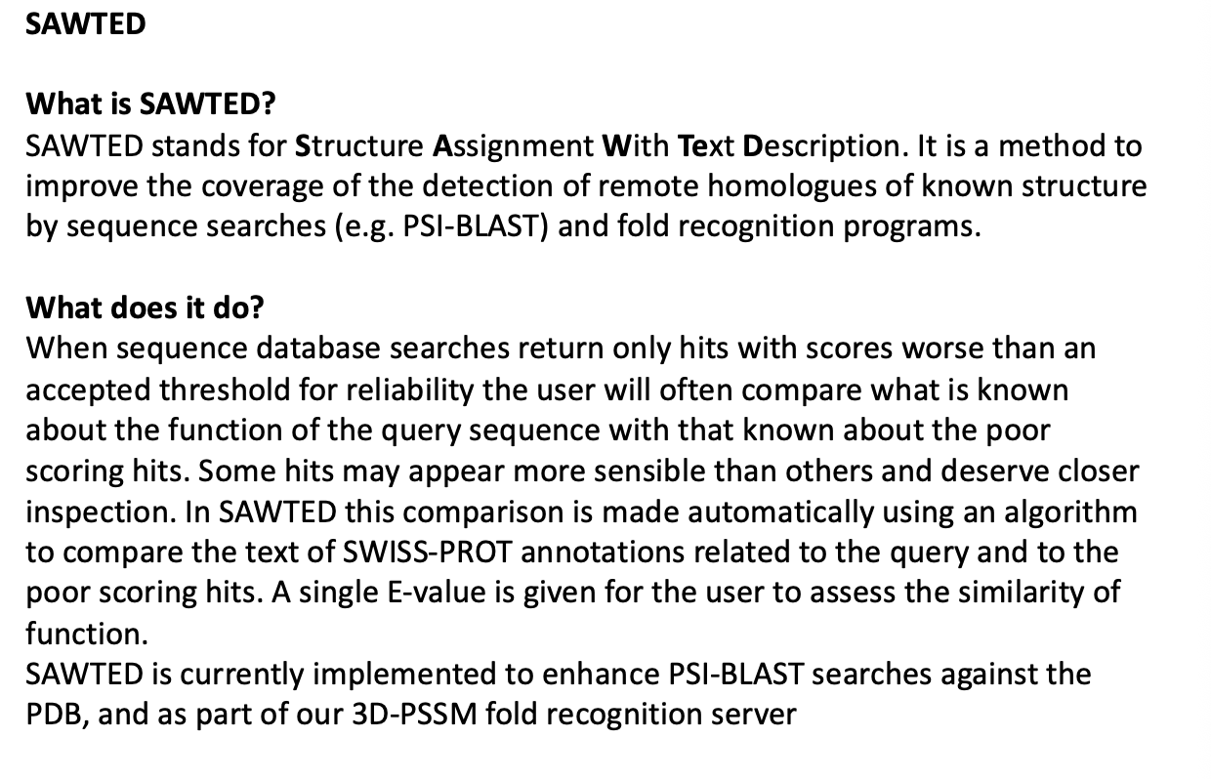

Instead of comparing the seq, compare the name of the protein (in uniport says kinase, and in PDB also says kinase), so align text, not seq of aa, align seq of text, compare text. If the alignment of the text has a good evaluate, there’s a common function found. In trembl is not curated, so there’s no titles.

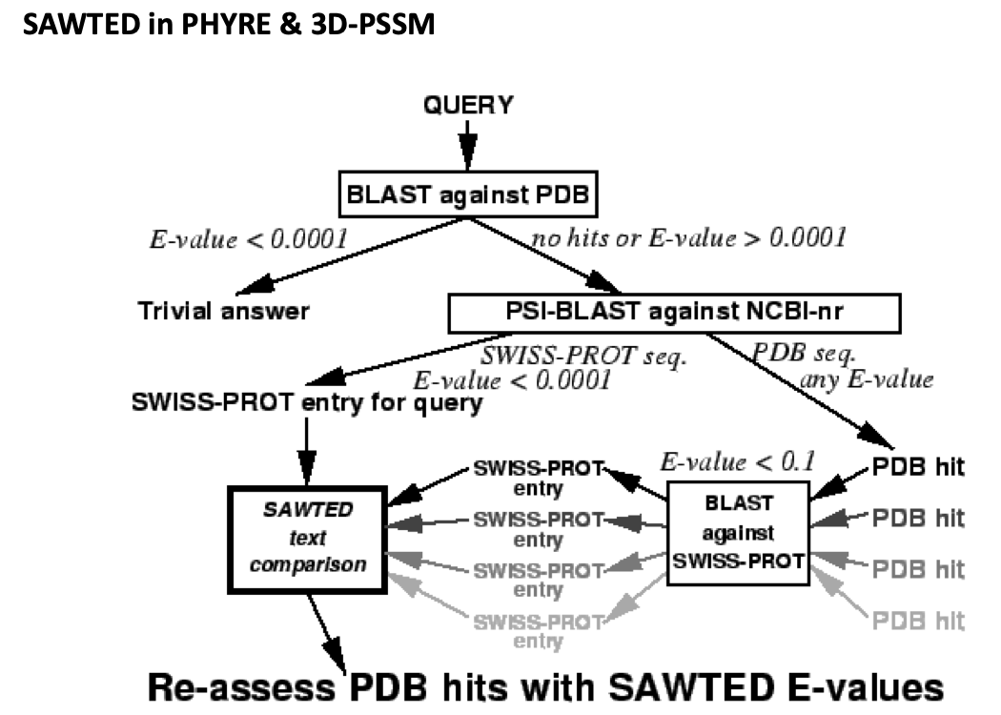

This is the schema for this method.

The same we can use pssm to describe structure, we can use this approach that describes function:

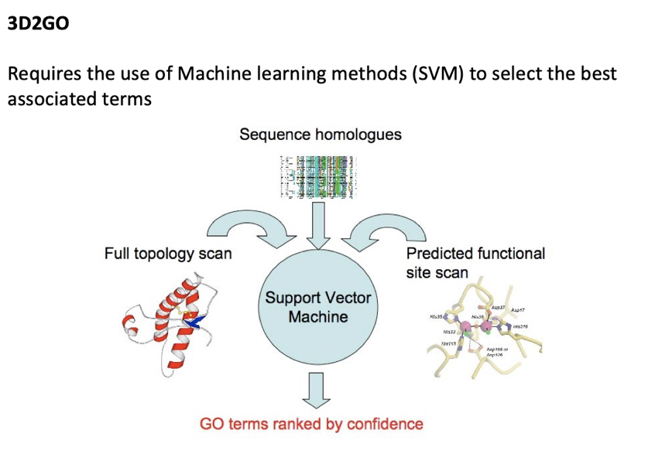GO = Gene Ontology 🡪 classify different -….

#### 6.1.2.1. Function association

What if we don’t have the sequences in uniport? What if they are from trembl? Here we don’t have no definitions, no descriptions, just the sequence.

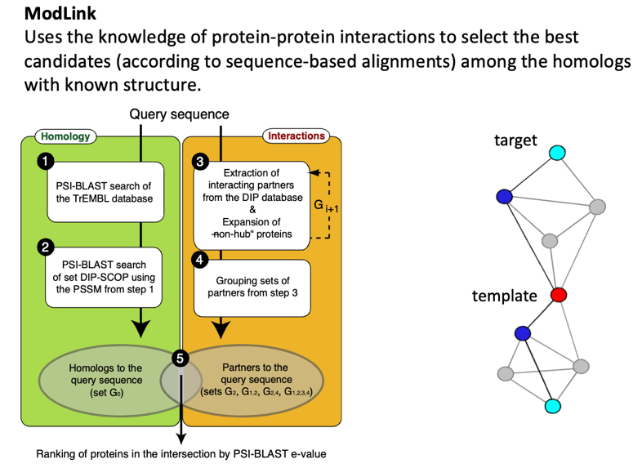

There is a lot of info coming from protein-protein interactions, I can substitute the idea of functions by interactions. Let’s say I target with unknown function, and then there’s another protein that have the same interaction as the target, and at least they might be the same, because interact with same interactions, similar functions as well.

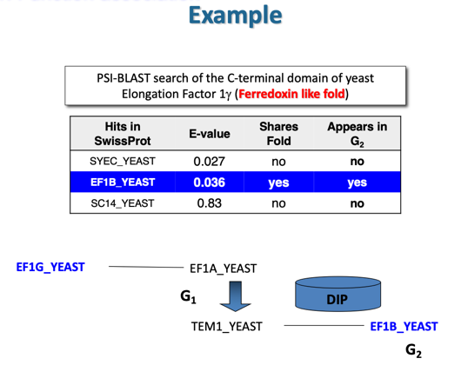For instance, doing this blind test:

First I take my seq and I see that interacts with E1A and is a G fam, and let’s see the fam the interact with this, and EF1B (Elongation Factor Beta). The relation is between A-C because theu interact with B so probably they have the same fold.

### 6.1.3. Secondary structure alignment

#### 6.1.3.1. Secondary structure prediction

* Machine learning theory

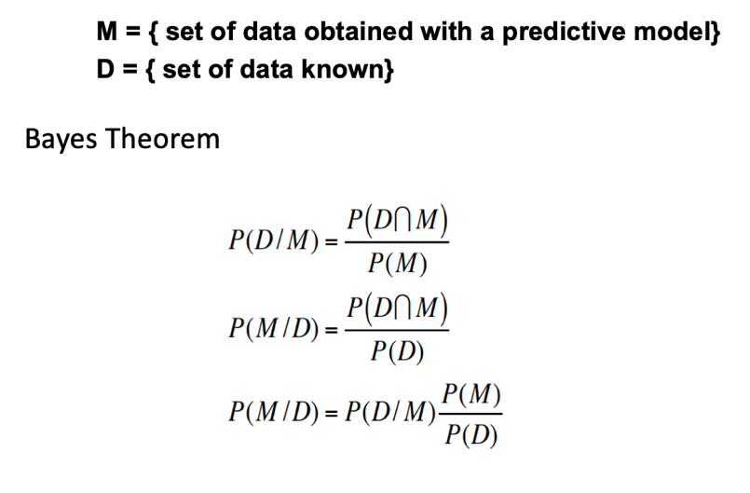

What is the probability of representing my data knowing the model.

I have the model when I know the data

Working with probabilities is hard, so work with log of probabilities (phy), and it maximum value will give me the maximum probability. Try to minimize P(D/M).

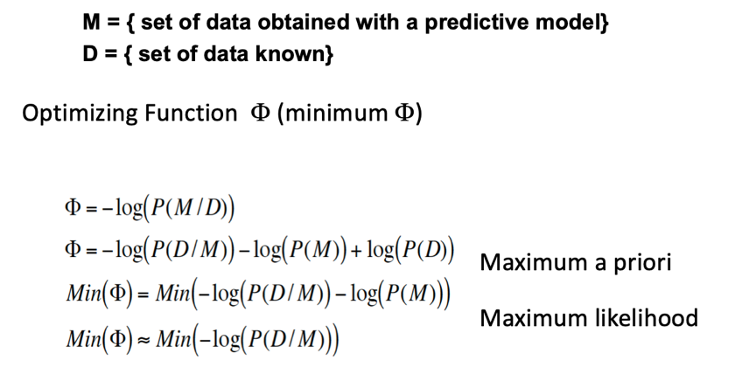

Split the data in to sets:

* + Training set : must be representative enough to test.
  + Test set: Cannot contain data from the training
* Neural Networks

Transform a set of vectors starting and a set of vectors at the end. To predict a secondary structure, there are 3 dimensions (so 3 possible vectors at the end), helix, strands and coil). Neuron is my model, and want to transform the vector into one single number, calculate scalar product (modulus).

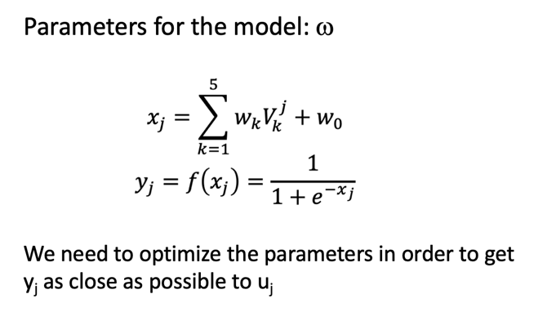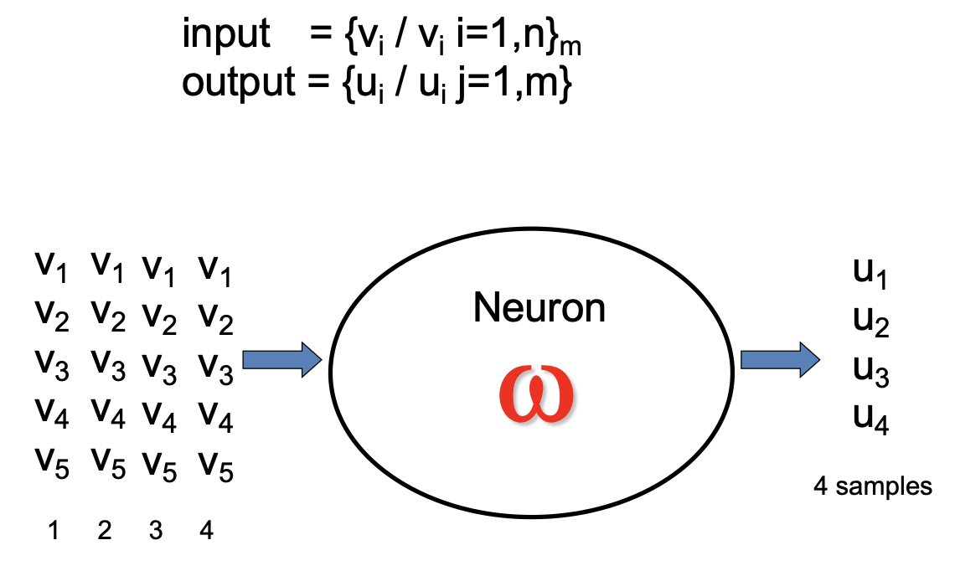

Value close to 1, values close to 0 and values close to -1, applying this function

For instance, fi 1 is helix, and I have 0.9 I will have a helix. So decide what is what, and in the output you take the decision.

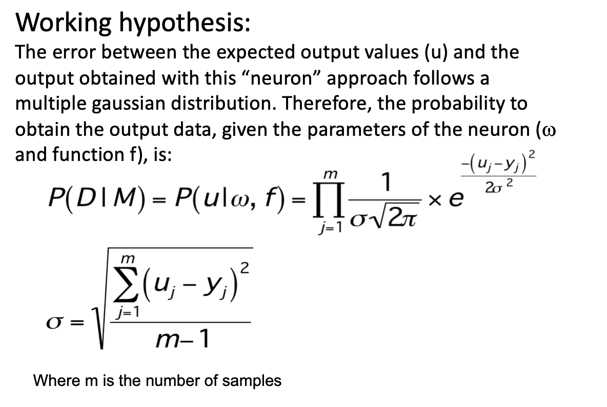

Compare the number I got with the real value (want this values as close as possible). Now that is the probability for the model, depending on the data, and I have to minimize, but what? We don’t know the parameters, I know the values of the vector, but I don’t know the parameters, the weights. By doing the log of this, we see how similar are my point to align, so try to optimize this by quadratic minima. I establish the derivative, to find the best optimal parameters.

That is for a single neuron, but if I have more than one neuron forming a layer, have to optimize many parameters. Forming at the end the NN. An in the input the vectors contain info regarding MSA. In the layer, there appears a second layer, and sometimes makes a prediction, to decide wether it is alpha, coil, etc.

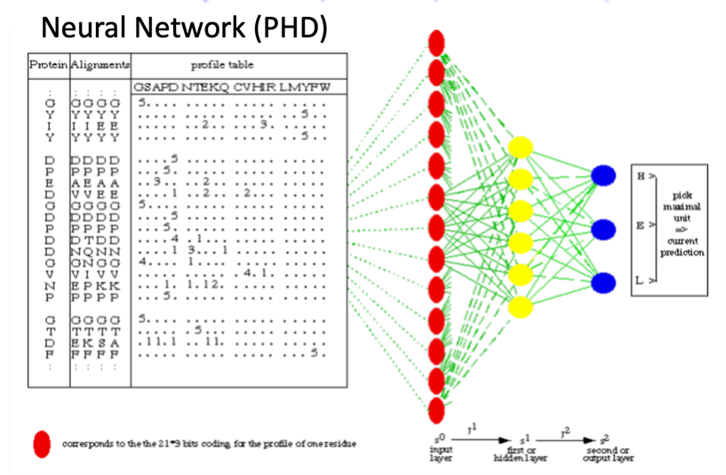

#### 6.1.3.2. Methods: TOPITS

To alignemtn of the secondary structure (truns) in PDB and for our prediction, threat the seq against the prediction.

## 6.2. ab initio fold prediction

### Revisiting the knowledge-based potential

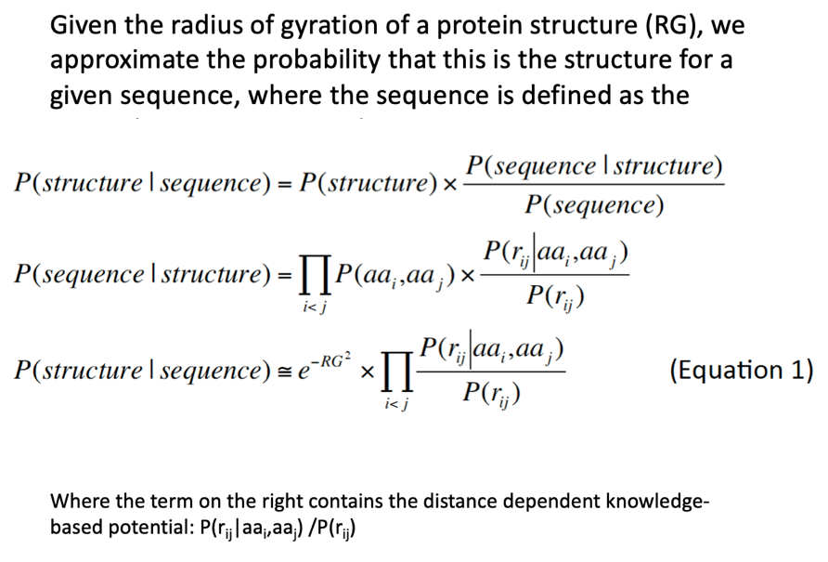

Instead of taking the whole structure, take just pairs, and the P of having certain residues at certain distance. Probability of certain distance P(rij).

### New potential based on conditional probabilities

Let’s say I want to calculate the probability of the whole sequence. I can say whether the aa is accessible or not P(aai|Ei). I don’t know the distance of the aa, just the environment. Takes into account the enivornmnt in which aa are found.

With residues hydrophilic, and charged are the ones more affected.

### 9-Fragment database of structures

ROSSETA: We have seq of 9 residues and search them in the db, and if they have similar seq, start with this structure, we can start in different position (either at the beginig, middle or at the end). Once we have the seq, we move to one residue left or right, and reconstruct. So it identifiers iteratively the obtained structures fromt his 9 residues. What might happen is that it can give more than one solution, so at some point we have many different structure, and with statistical potentials, we make a ranking, taking only the best 50 best structures. And at some point the structure will have some kind of surface. Takes a lot of time and computational power.

The potential are applied to the whole structure, the fragments are chosen based on the comparison of fragments to the seq.

### Simulated annealing construction

iTASSER: why don’t just use 20 res and speed up this mechanism. First try the LOMETS method, using the results of several threading approaches based on remote homology and select the common fragment-templates (cluster), ending up with the same type of folds. Take these clusters, check again he model, and calculate the energy., following similar approach to Rossetta.

### Mutual information

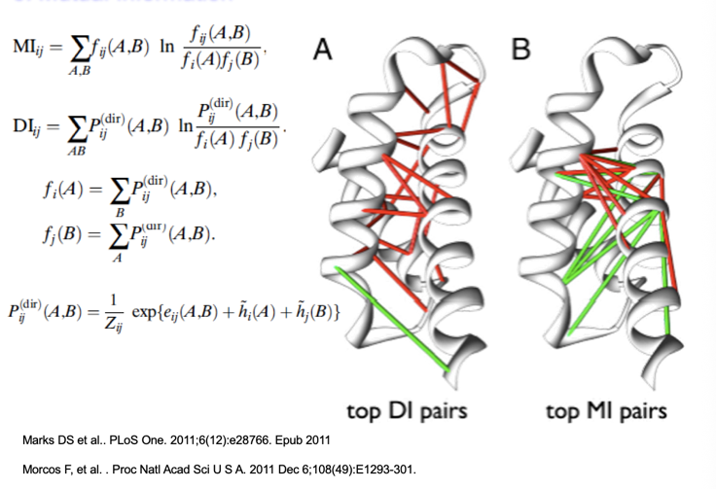If we have a MSA there are residues, and if at some point there is some substitution. Here there is correlation between substitution to aa that are similar, that’s called mutual information. If the aa are correlated, the mutual information is high, so use this to infer when two residues are correlated, or not. One of the properties of correlations, A~B and B~C, A and B therefore correlate (A~B). But might not happen in the 3D structure.

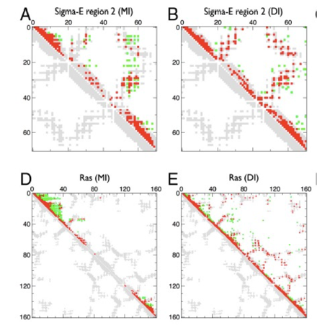

We can sue the energy for terms of pairs and if we are able to describe this, we can recalculate the pure probabilities to infer where is the real pair correlated positions.

This is a contact map (seq of a protein, and every dot is aa are in a distance shorter than 8A (baldo did not remember well), from the MSA. If we are able to represent this content map, we are able to represent the structure.

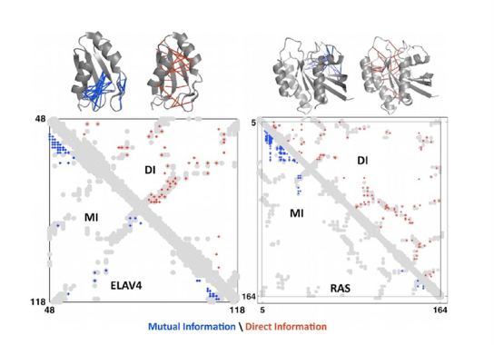

The halfs are the same, in one (blue) represent Mutal Information, and in red represent the Direct information

### CASP (Critical assessment of Structure Prediction)

For each aa lookt at the environment, so locally compared these models, and is called GDT:

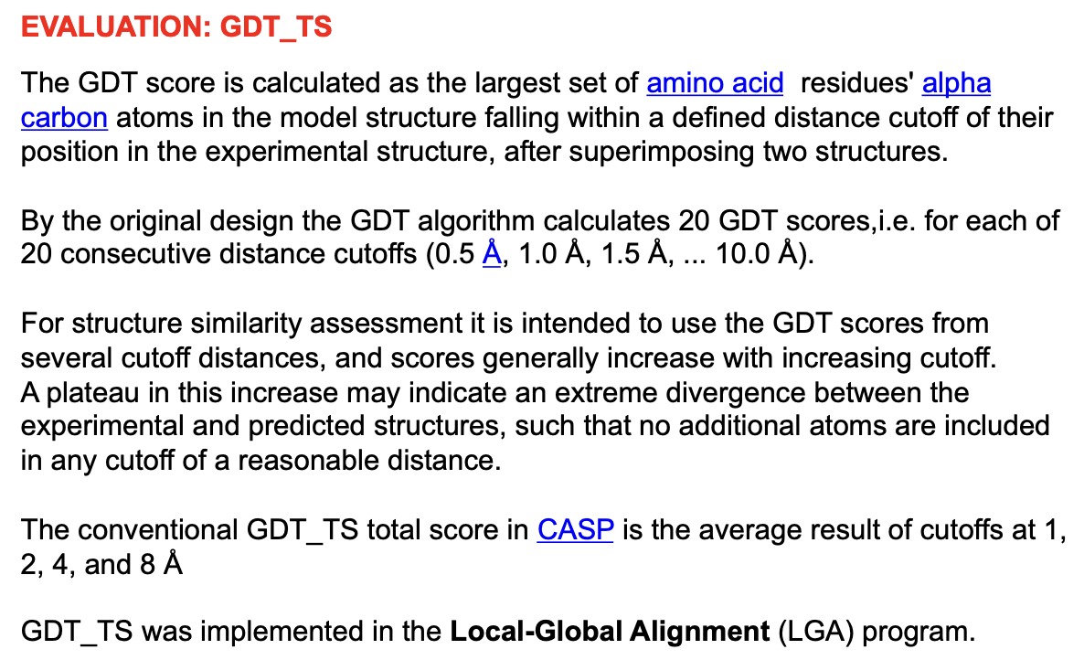

Use this as a measure.

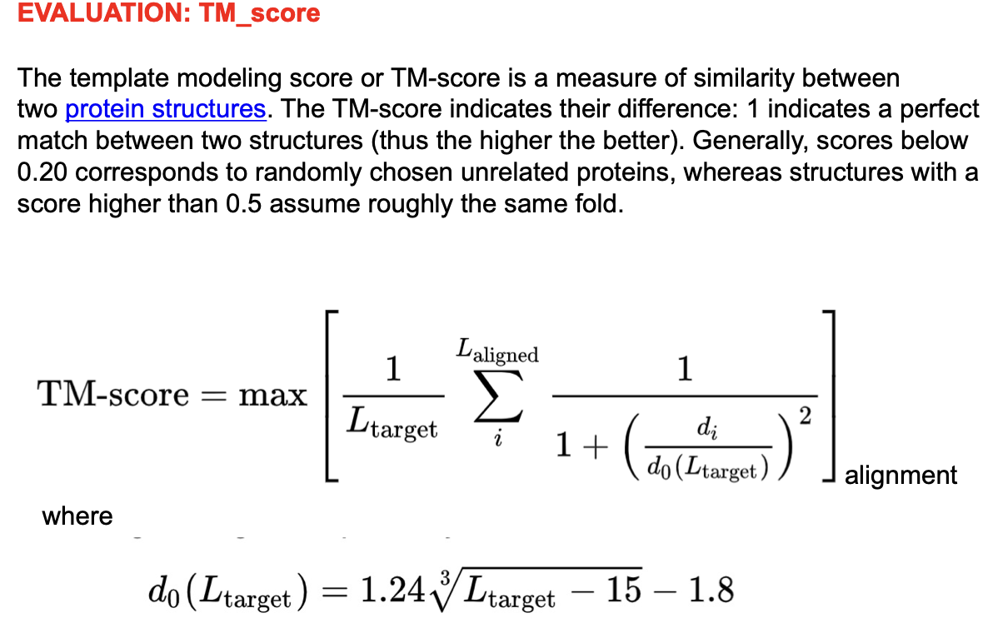

Values higher than 0.5 find similar structures.

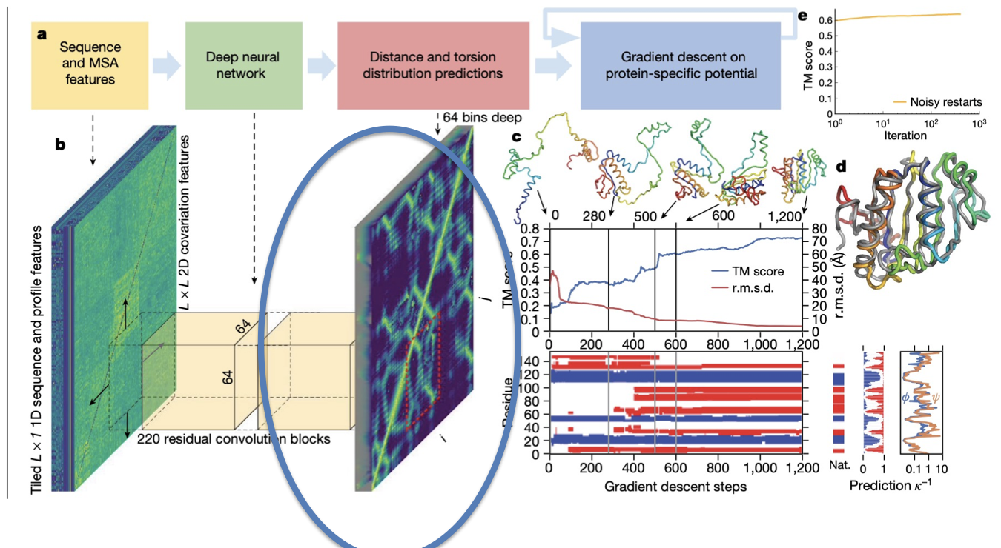

## 6.3. Protein folding

With dynamic simulations

1. The peptide bond is not a simple single bond. Because of resonance, the electrons are shared in two possible structures, one looks like a normal single bond (C-N) and the other looks like a double bond (C=N).